**Institute of Information Technology (IIT)**

Jahangirnagar University



**ICT 4102– Artificial Intelligence Lab**

**LAB REPORT**

**SUBMITTED BY**

Name: Md. Shakil Hossain  
Roll No: 2023

Exam Roll: 192340  
Submission Date: 05/09/2023

**SUBMITTED TO**

Md. Mahmudur Rahman

Lecturer, IIT

**Contents**

1. **Lab Report: 01** 4
2. Example 1: 5
3. Example 2: 6
4. Example 3: 6
5. Example 4: 7
6. Example 5: 8
7. Example 6: 9
8. Example 7: 10
9. Example 8: 11
10. Example 9: 12
11. Example 10: 15
12. Example 11: 16
13. Example 12: 17
14. **Lab Report: 02** 18
15. Problem name : Comparison-1: 19
16. Problem name: Comparison-2: 20
17. Problem Name: Recursion 21
18. Problem Name: Factorial 22
19. Problem Name: Descendent 22
20. Problem Name: List 23
21. Problem Name: Member of List 24
22. Problem Name: Concat List 24
23. Problem name: Delete List 25
24. Problem Name: Deleting from an item 25
25. Problem Name: Adding an item 27
26. Problem Name: Implement a Prolog predicate ‘equal_length/2’ that takes two lists as input and succeeds if both lists have the same length .Give some example queries and their expected outputs. 27
27. Prolog predicate ‘maximum/3’ that takes three integers as input and returns the maximum of the three. 28
28. Write a Prolog predicate to find the length of a list 29
29. **Lab Report: 03** 30
30. Exercise 01: 31
31. Exercise 02: 31
32. Exercise 03: 32
33. Exercise 04: 32
34. Exercise 05: 33
35. Exercise 06: 34
36. Exercise 07: 34
37. Exercise 08: 35
38. Exercise 09: 35
39. Exercise 10: 36
40. Exercise 11: 36
41. Exercise 12: 37
42. Exercise 13: 37
43. Exercise 14: 38
44. Exercise 15: 38
45. **Lab Report: 04** 39
46. **Lab Report: 05** 53
47. **Lab Report: 06** 64
48. **Lab Report: 07** 77
49. **Lab Report: 08** 85

**Institute of Information Technology (IIT)**

Jahangirnagar University



# **Lab Report: 01**

Submitted by:

Name: Md. Shakil Hossain  
Roll No: 192340

Lab Date: 23/05/2023  
Submission Date: 29/05/2023

**Lab Report # Day 01**

## Example 1:

Knowledge Base 1.

**Clause:**

*woman(mia).*

*woman(jody).*

*woman(yolanda).*

*playsAirGuitar(jody).*

*party.*

**Queries:**

?- woman(mia).

?- playsAirGuitar(jody).

?- playsAirGuitar(mia).

?- tattoed(jody).

?- party.

?- rockConcert.

**Result:**

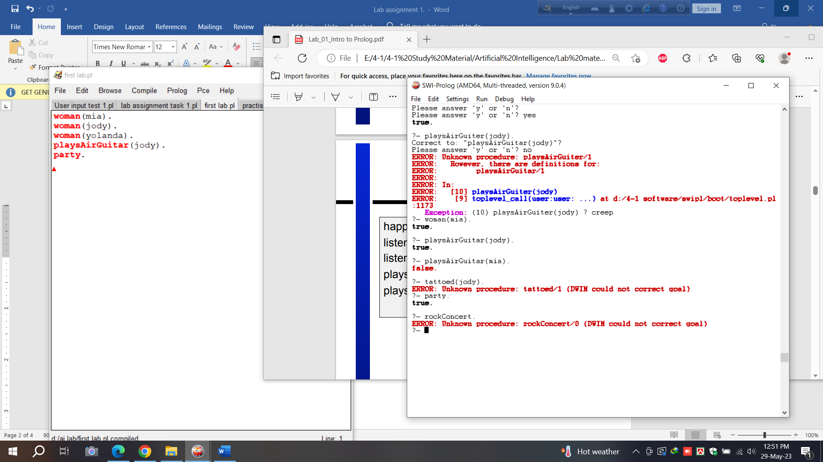

## Example 2:

Knowledge Base 2.

**Clause:**

*happy(yolanda).*

*listens2music(mia).*

*listens2music(yolanda):- happy(yolanda).*

*playsAirGuitar(mia):- listens2music(mia).*

*playsAirGuitar(yolanda):- listens2music(yolanda).*

**Queries:**

?- playsAirGuitar(mia).

?- playsAirGuitar(yolanda).

**Result:**

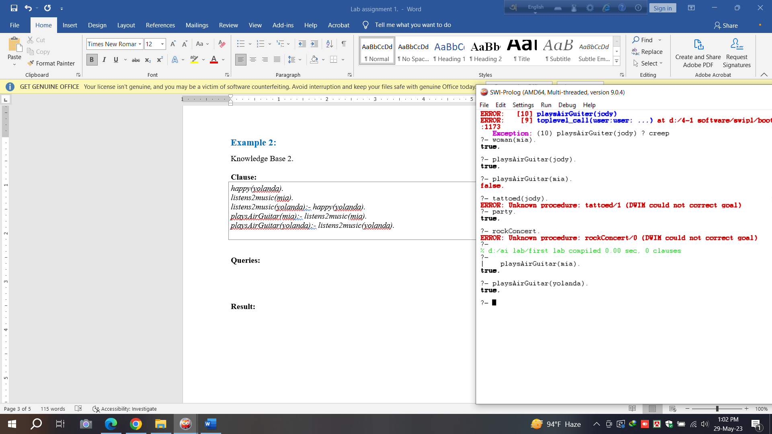

## Example 3:

Knowledge Base 3.

**Clause:**

*happy(vincent).*

*listens2music(butch).*

*playsAirGuitar(vincent):- listens2music(vincent), happy(vincent).*

*playsAirGuitar(butch):- happy(butch).*

*playsAirGuitar(butch):- listens2music(butch).*

**Queries:**

?- playsAirGuitar(vincent).

?- playsAirGuitar(butch).

**Result:**

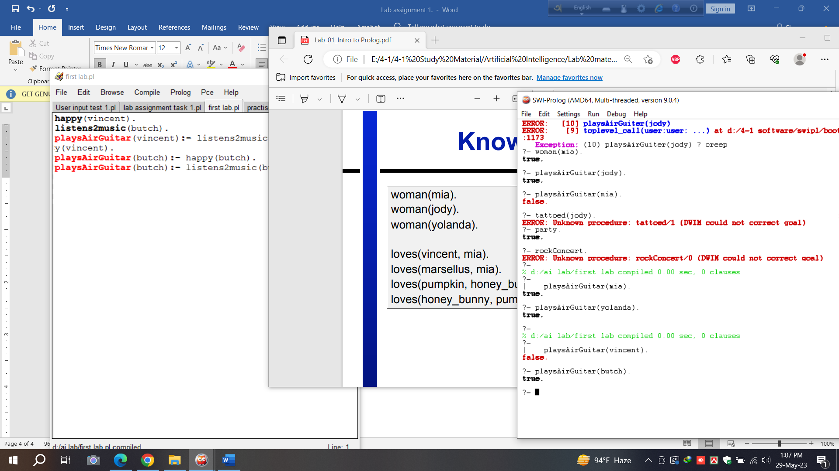

## Example 4:

Knowledge Base 4.

**Clause:**

*woman(mia).*

*woman(jody).*

*woman(yolanda).*

*loves(vincent, mia).*

*loves(marsellus, mia).*

*loves(pumpkin, honey_bunny).*

*loves(honey_bunny, pumpkin).*

**Queries:**

?- woman(X).

?- loves(marsellus,X), woman(X).

?- loves(pumpkin,X), woman(X).

**Result:**

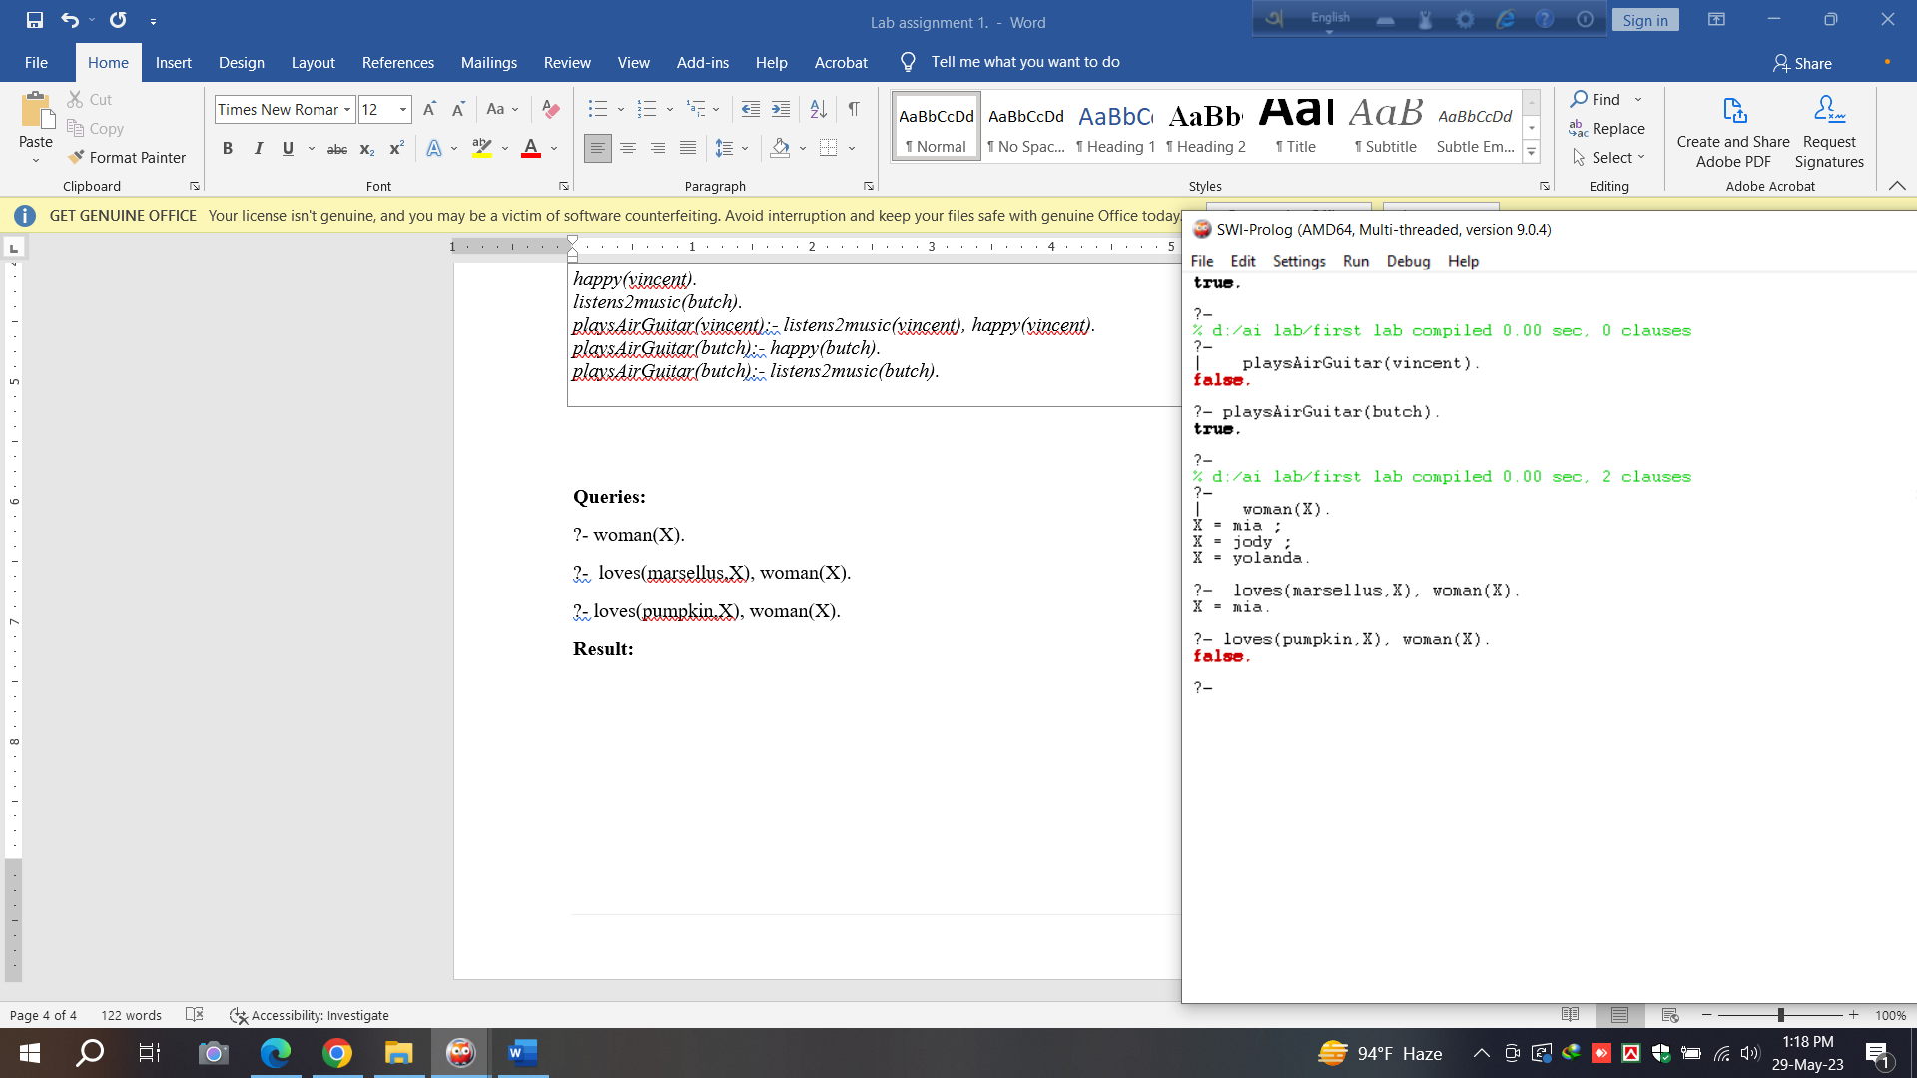

## Example 5:

Knowledge Base 5.

**Clause:**

*loves(vincent,mia).*

*loves(marsellus,mia).*

*loves(pumpkin, honey_bunny).*

*loves(honey_bunny, pumpkin).*

*jealous(X,Y):- loves(X,Z), loves(Y,Z).*

**Queries:**

?- jealous(marsellus,W).

**Result:**

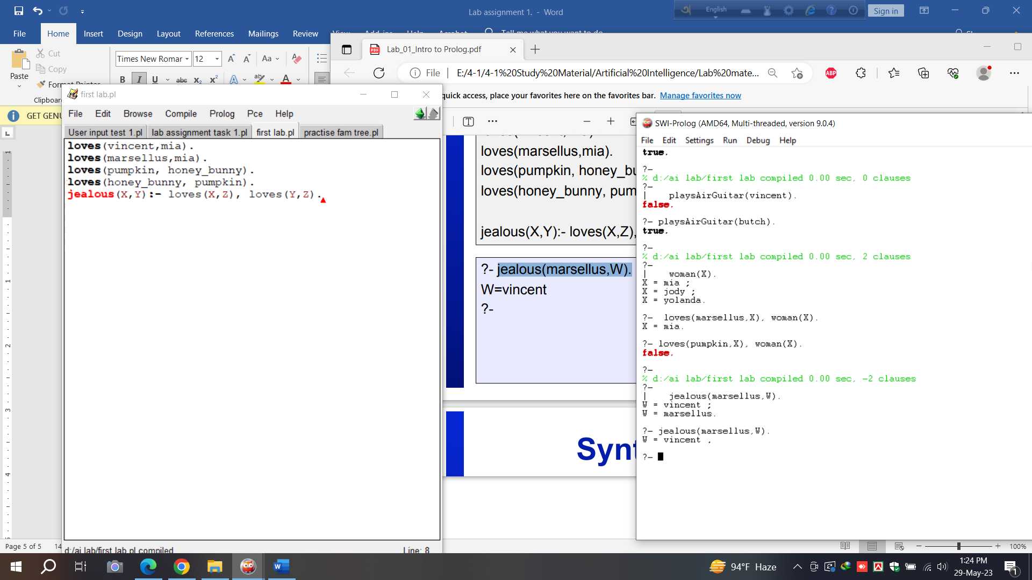

## Example 6:

Exercise 1: Read & write two numbers

**Clause:**

*start:-*

*write('enter your first num'),nl,*

*read(X),nl,*

*write('enter your second num'),nl,*

*read(Y),nl,*

*write('here is your numbers'),nl,*

*write(X),nl,*

*write(Y).*

**Queries:**

?- start.

**Result:**

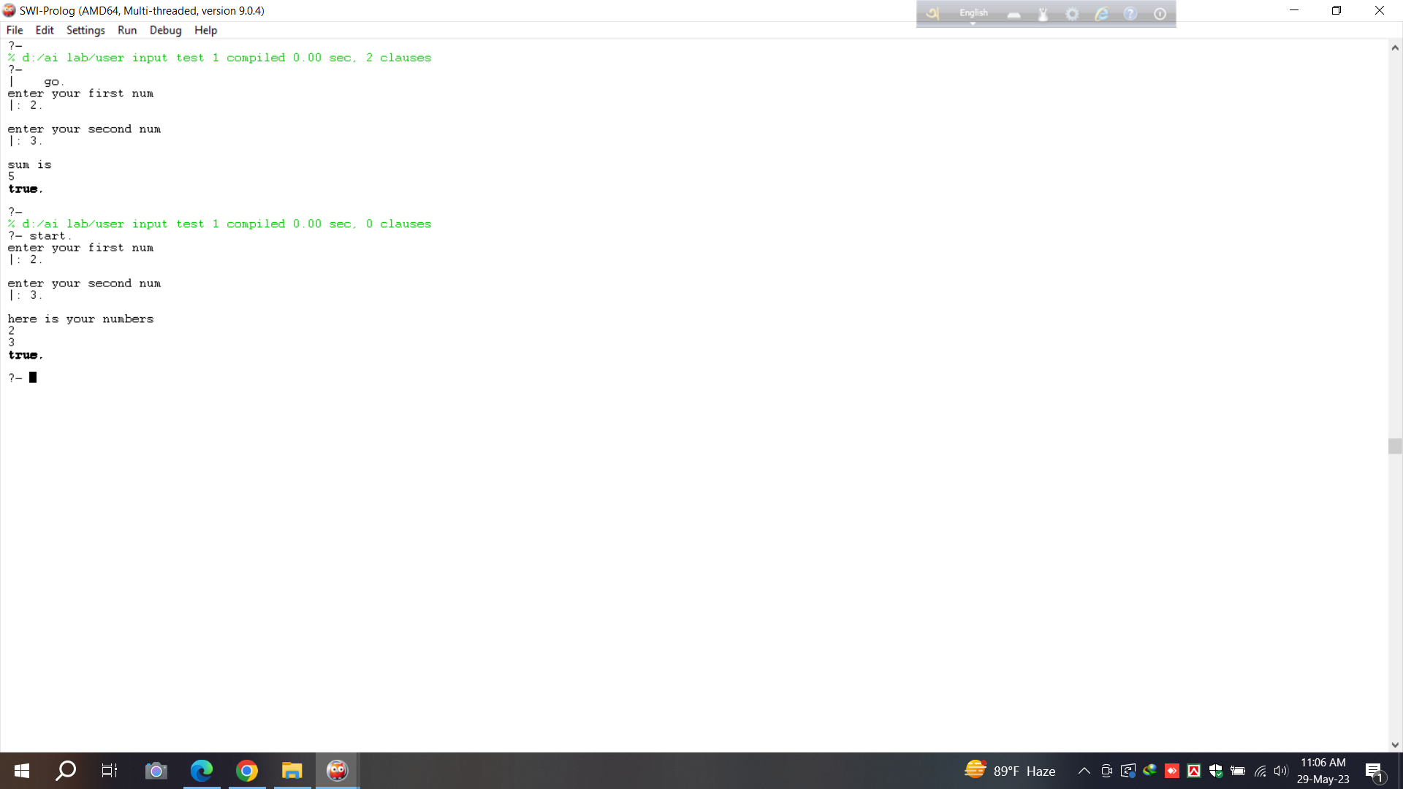

## Example 7:

Exercise 2: Sum of two numbers

**Clause:**

*go:-*

*write('enter your first num'),nl,*

*read(X),nl,*

*write('enter your second num'),nl,*

*read(Y),nl,*

*sum(X,Y).*

*sum(X,Y):-S is (X+Y),*

*write('sum is'),nl,*

*write(S).*

**Queries:**

?- go.

**Result:**

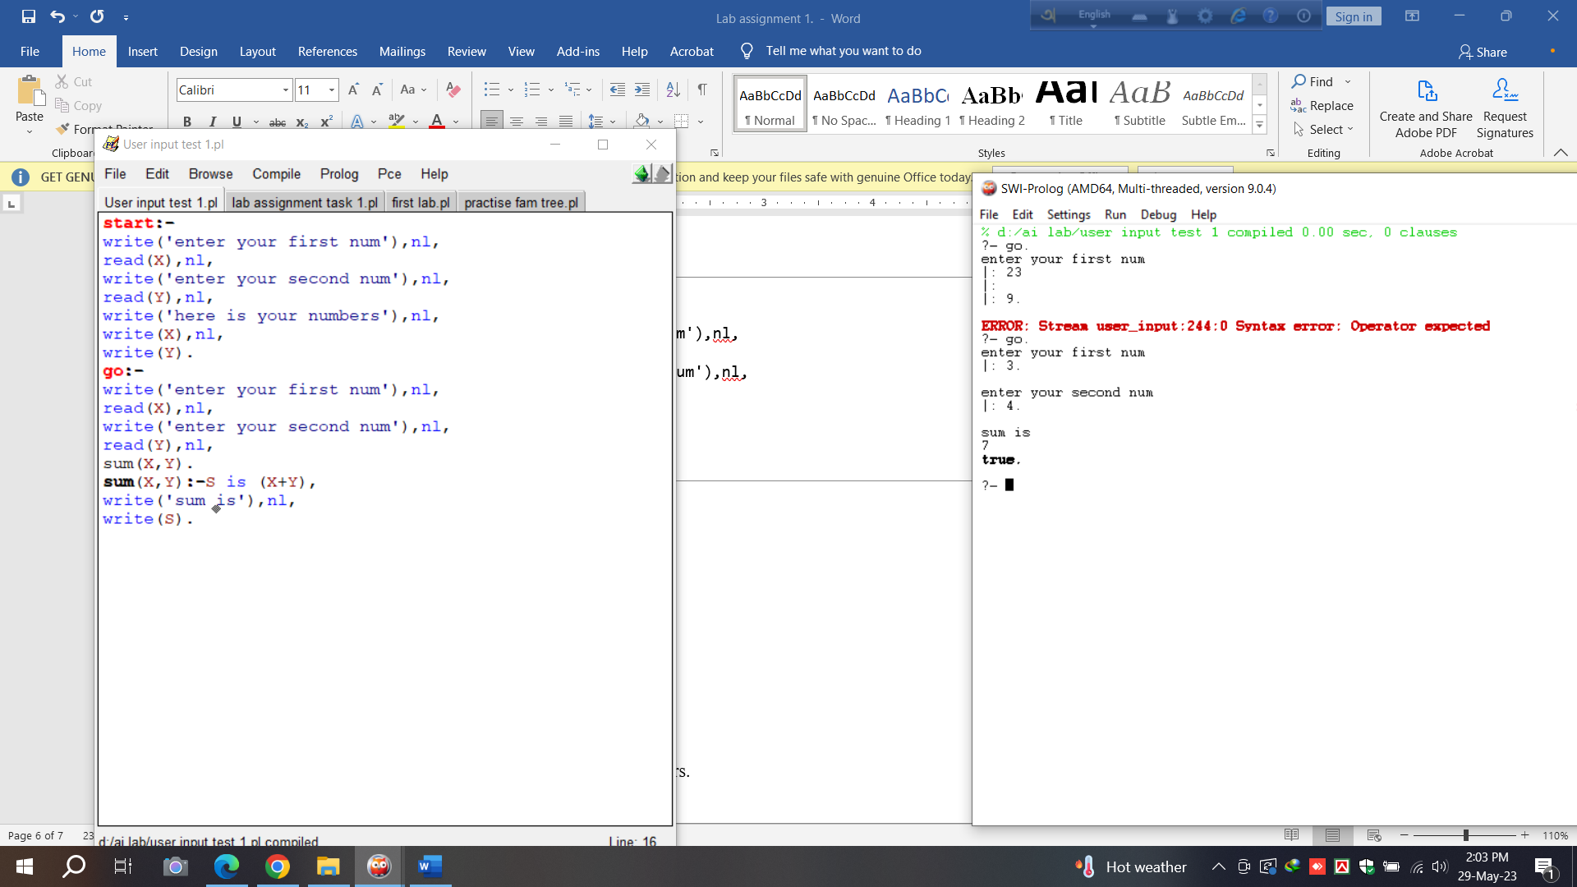

## Example 8:

Task 1: Average of three numbers.

**Clause:**

*go:-*

*write('enter your first num'),nl,*

*read(X),nl,*

*write('enter your second num'),nl,*

*read(Y),nl,*

*write('enter your third num'),nl,*

*read(Z),nl,*

*sum(X,Y,Z).*

*sum(X,Y,Z):-S is ( X+Y+Z )/3,*

*write('average is'),nl,*

*write(S).*

**Queries:**

?- go.

**Result:**

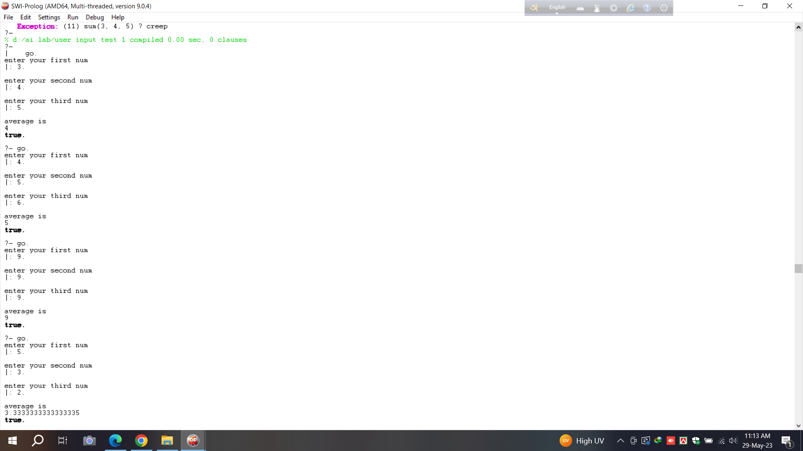

## Example 9:

Task 2: Family Tree

**Clause:**

|  |
| --- |
| *ml(jamil).*  *ml(sohel).*  *ml(rafi).*  *ml(rumi).*  *ml(raj).*  *ml(orko).*  *ml(jarif).*  *ml(ovi).*  *femle(runa).*  *femle(riya).*  *femle(najia).*  *femle(ridima).*  *femle(sufi).*  *femle(saki).*  *parent(jamil,runa).*  *parent(jamil,sohel).*  *parent(runa,rafi).*  *parent(runa,rumi).*  *parent(runa,riya).*  *parent(sohel,najia).*  *parent(sohel,ridima).*  *parent(rafi,raj).*  *parent(rumi,sufi).*  *parent(najia,saki).*  *parent(najia,orko).*  *parent(sufi,jarif).*  *parent(orko,ovi).*  *siblings(X,Y):- parent(Z,X),parent(Z,Y),X\=Y.*  *moter(X,Y):-parent(X,Y),femle(X).* |

**Queries:**

?- ml(runa).

?- ml(sohel).

?- ml(jarif).

?- femle(sufi).

?- femle(ridima).

?- parent(jamil,_).

?- parent(sufi,_).

?- parent(saki,_).

?- parent(rumi,_).

?- parent(runa,X).

?- parent(jamil,X).

?- siblings(rafi,X).

?- siblings(najia,X).

?- moter(X,riya).

?- moter(X,orko).

**Result:**

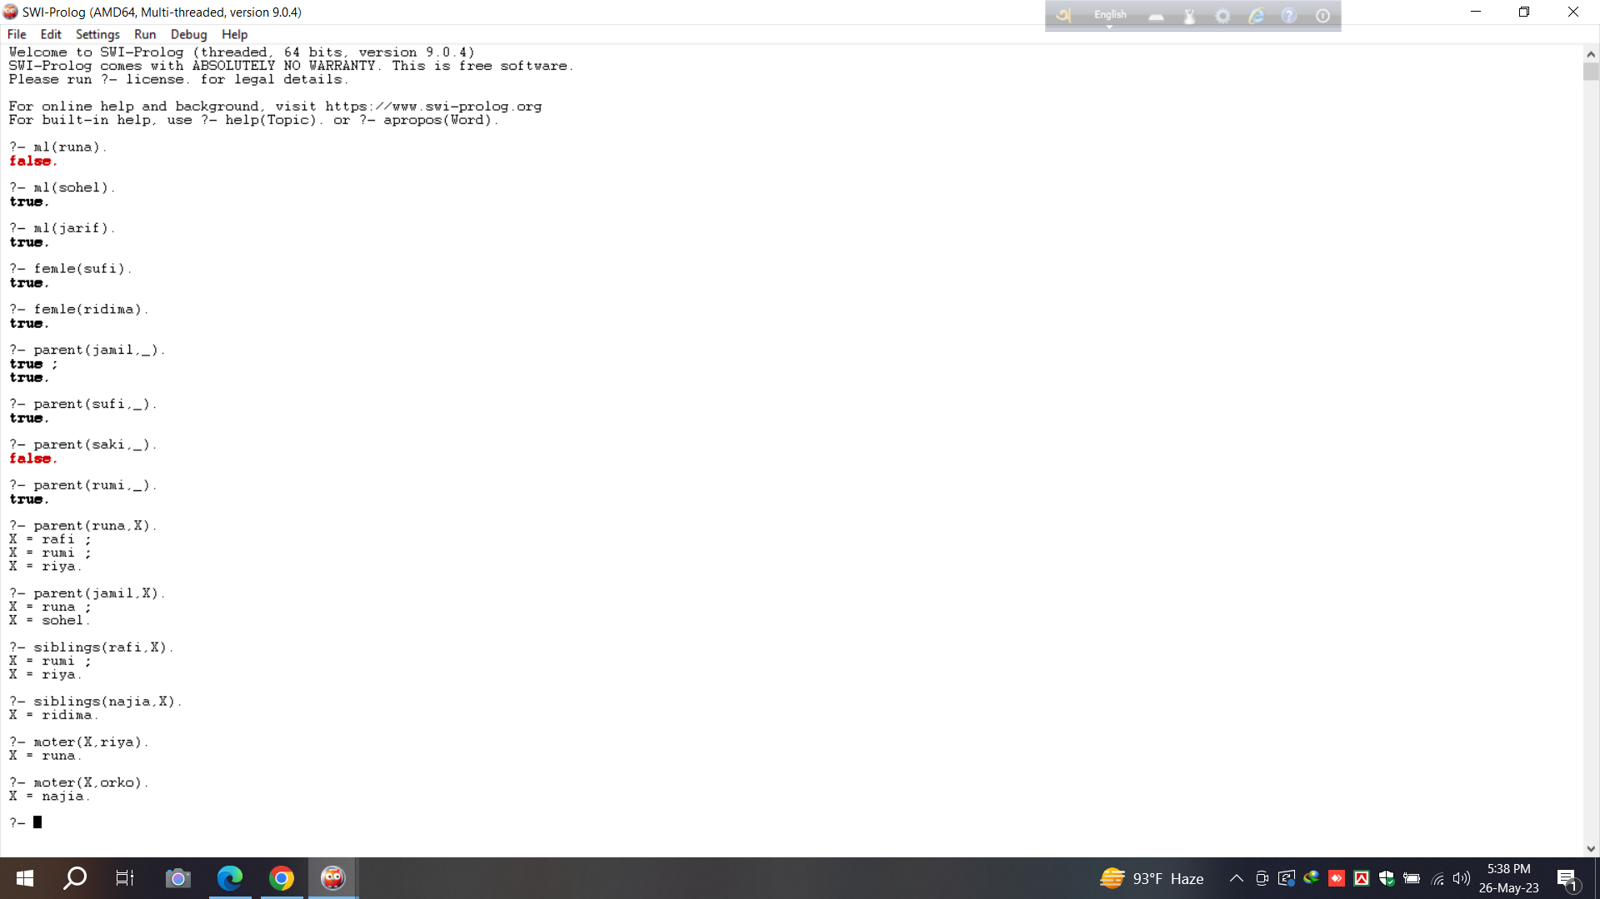

## Example 10:

**Problem Name :** Addition/Subtraction/Multiplication/Division/Power

**Queries :**

1) A is 1023+34+98.

2) S is 64-89

3) M is 78*54.

4) D is 67/34.

**Results:**

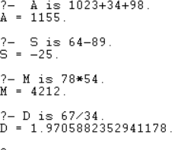

## Example 11:

**Problem Name:** Min/Max **Queries:**

MAXIMUM is max(23,-9).

1. MAXIMUM is max(-23,-9).
2. MINIMUM is min(2014,2450).

**Result:**

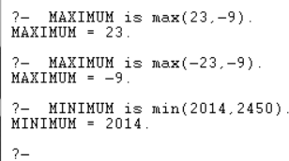

## Example 12:

**Problem Name :**Underscore **Clause :**

division(dhaka,rajshahi,khulna).

**Queries:**

1. division(X,Y,Z).
2. division(_,_,Z).

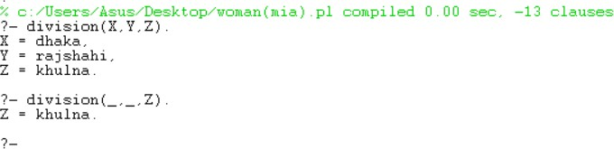**Result:**

**Institute of Information Technology (IIT)**

Jahangirnagar University



# **Lab Report: 02**

Submitted by:

Name: Md. Shakil Hossain  
Roll No: 192340

Lab Date: 08/06/2023  
Submission Date: 12/06/2023

**Lab Report # Day 01**

## Problem name : Comparison-1:

**Clause:**

*read(X),nl,*

*goal(X,Y),nl,*

*write('Section A country score is '),nl,*

*write(Y),nl,*

*write('enter section B country name'),nl,*

*read(P),nl,*

*goal(P,Q),nl,*

*write('Section B country score is '),nl,*

*write(Q),nl,*

*compare(Y,Q).*

*compare(Y,Q):-*

*Y>Q,nl,*

*write('Section A country is the winner');*

*Y<Q,nl,*

*write('Section B country is the winner');*

*Y=:=Q,nl,*

*write('Draw in both section').*

**Queries:**

**Result:**

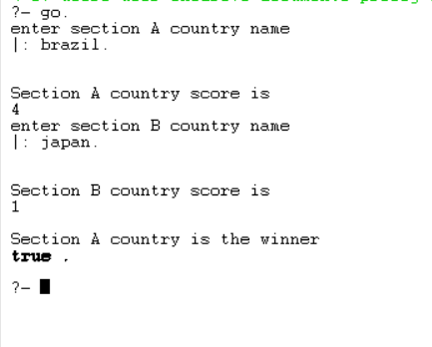

## Problem name: Comparison-2:

**Clause:**

*go:-*

*write('enter section A country name'),nl,*

*read(X),nl,*

*goal(X,Y),nl,*

*write('Section A country score is '),nl,*

*write(Y),nl,*

*write('enter section B country name'),nl,*

*read(P),nl,*

*goal(P,Q),nl,*

*write('Section B country score is '),nl,*

*write(Q),nl,*

*compare(Y,Q).*

*compare(Y,Q):-*

*Y>Q,nl,*

*write('Section A country is the winner');*

*Y<Q,nl,*

*write('Section B country is the winner');*

*Y=:=Q,nl,*

*write('Draw in both section').*

**Queries:**

**Result:**

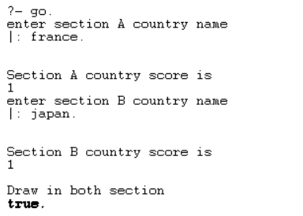

## Problem Name: Recursion

**Clause:**

*% Base case: Factorial of 0 is 1*

*factorial(0, 1).*

*% Recursive case: Calculate factorial of N as N multiplied by factorial of N-1*

*factorial(N, Result) :-*

*N > 0,*

*N1 is N - 1,*

*factorial(N1, SubResult),*

*Result is N * SubResult.*

**Queries:**

**Result:**

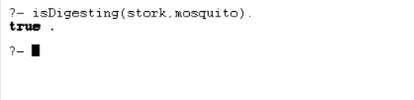

## Problem Name: Factorial

**Clause:**

*woman(mia).*

*woman(jody).*

*woman(yolanda).*

*loves(vincent, mia).*

*loves(marsellus, mia).*

*loves(pumpkin, honey_bunny).*

*loves(honey_bunny, pumpkin).*

**Queries:**

?- woman(X).

?- loves(marsellus,X), woman(X).

?- loves(pumpkin,X), woman(X).

**Result:**

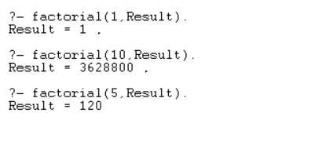

## Problem Name: Descendent

**Clause:**

*child(anna,bridget).*

*child(bridget,caroline).*

*child(caroline,donna).*

*child(donna,emily).*

*descend(X,Y):- child(X,Y).*

*descend(X,Y):- child(X,Z), descend(Z,Y).*

**Queries:**

**Result:**

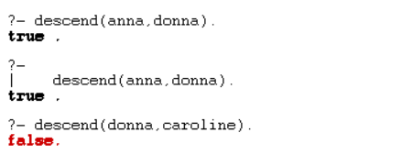

## Problem Name: List

**Result:**

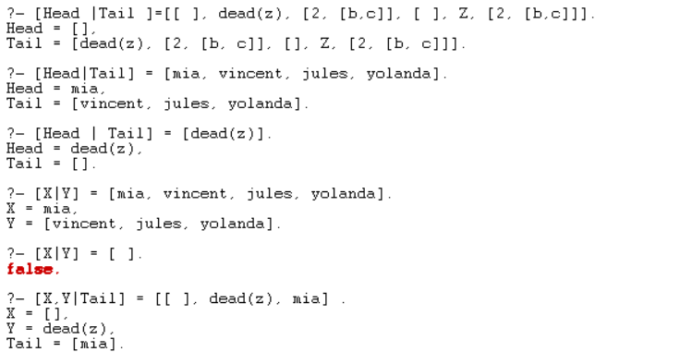

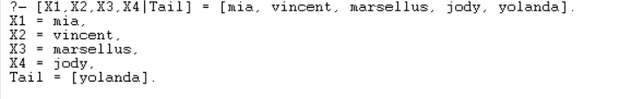

## Problem Name: Member of List

**Result:**

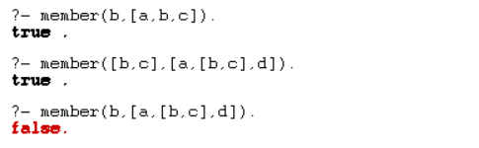

## Problem Name: Concat List

**Clause:**

*concat_lists(L1, L2, Concat) :- append(L1, L2, Concat)*

**Queries:**

**Result:**

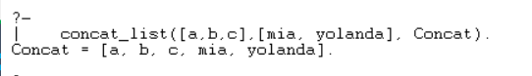

## Problem name: Delete List

**Clause:**

|  |
| --- |
| *delete_last([_], []). delete_last([Head|Tail], [Head|NewTail]) :- delete_last(Tail, NewTail).* |

**Queries:**

**Result:**

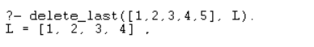

## Problem Name: Deleting from an item

**Clause:**

|  |
| --- |
| *delete_item(X,[X|Tail],Tail).*  *delete_item(X,[Y|Tail],[Y|Tail1]):- delete_item(X,Tail,Tail1).* |

**Queries :**

?- delete_item(a,[d,b,a,c],New_list).

New_list = [d, b, c].

**Results:**

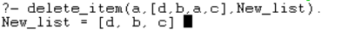

## Problem Name: Adding an item

**Clause:**

|  |
| --- |
| *add_item(Item, List, NewList) :- append(List, [Item], NewList).* |

**Queries:**

?- add_item(dena,[hiyana,dona,mia],L).

L = [hiyana, dona, mia, dena].

**Result:**

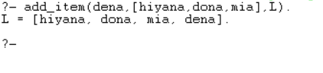

## Problem Name: Implement a Prolog predicate ‘equal_length/2’ that takes two lists as input and succeeds if both lists have the same length .Give some example queries and their expected outputs.

**Clause:**

|  |
| --- |
| *equal_length([], []).*  *equal_length([H|T], [H1|T1]) :-*  *length([H|T]) = length([H1|T1]),*  *equal_length(T, T1).* |

**Queries:**

?- equal_length([], []).

?- equal_length([1, 2, 3], [1, 2, 3]).

?- equal_length([1, 2], [1, 2, 3]).

**Result:**

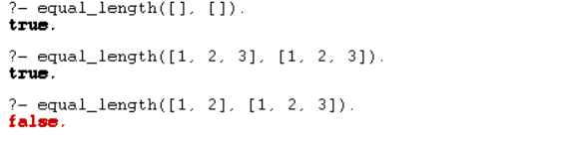

## Prolog predicate ‘maximum/3’ that takes three integers as input and returns the maximum of the three.

**Clause:**

|  |
| --- |
| *maximum(A, B, C) :-*  *A >= B,*  *A >= C,*  *write('Max = '),write(A).*  *maximum(A, B, C) :-*  *B >= A,*  *B >= C,*  *write('Max = '),write(B).*  *maximum(A, B, C) :-*  *C >= A,*  *C >= B,*  *write('Max = '),write(C).* |

**Queries:**

?- maximum(4,6,9).

?- maximum(7,200,101).

?- maximum(501,200,101).

**Result:**

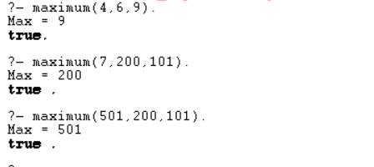

## Write a Prolog predicate to find the length of a list

**Clause:**

|  |
| --- |
| *list_length([],0).*  *list_length([_|TAIL],N) :- list_length(TAIL,N1), N is N1 + 1.* |

**Queries:**

?- list_length([a,b,c,d],Len)

?- list_length([a,b,c,[f,g],[]],Len).

**Result:**

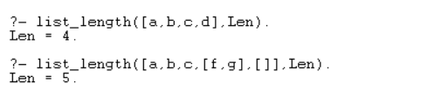

Institute of Information Technology (IIT)

Jahangirnagar University



# **Lab Report: 03**

Submitted by:

Name: Md. Shakil Hossain

Roll No: 2023

Lab Date: 14-June-2023

Submission Date: 22-June 2023

## Exercise 01:

**Lab Report: Day 03**

**Problem Name**: Write a Python program to find the sum of all the elements in a list.

**Code:**

list=[3,5,4,7,8,1,0,8,4]

total=0

for i in list: total+=i

print(f"Sum of list : {total}")

**Output:**



## Exercise 02:

**Problem Name**: Write a Python program to find the largest, smallest, second largest, and second smallest elements in a list.

**Code:**

list=[3,5,4,7,9,1,0,8,4]

list.sort()

print(f"The list : {list}") print(f"Largest : {list[-1]}")

print(f"Smallest : {list[0]}") print(f"Second Largest : {list[-2]}") print(f"Second Smallest : {list[1]}")

**Output:**

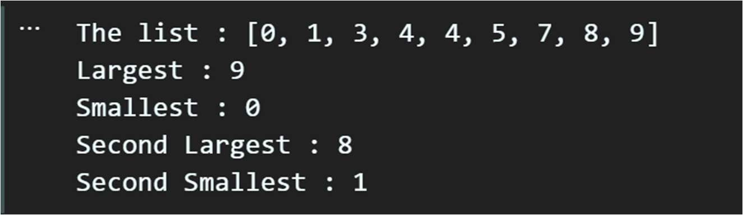

## Exercise 03:

**Problem Name**: Write a Python program to count the number of occurrences of each character in a string.

**Code:**

def charcount(string): count={}

for i in string: if i in count:

count[i]+=1 else:

count[i]=1 return count

string="Beekeepers keep bees" chars=charcount(string)

for char in chars:

print(f"{char} :: {chars[char]}")

**Output:**

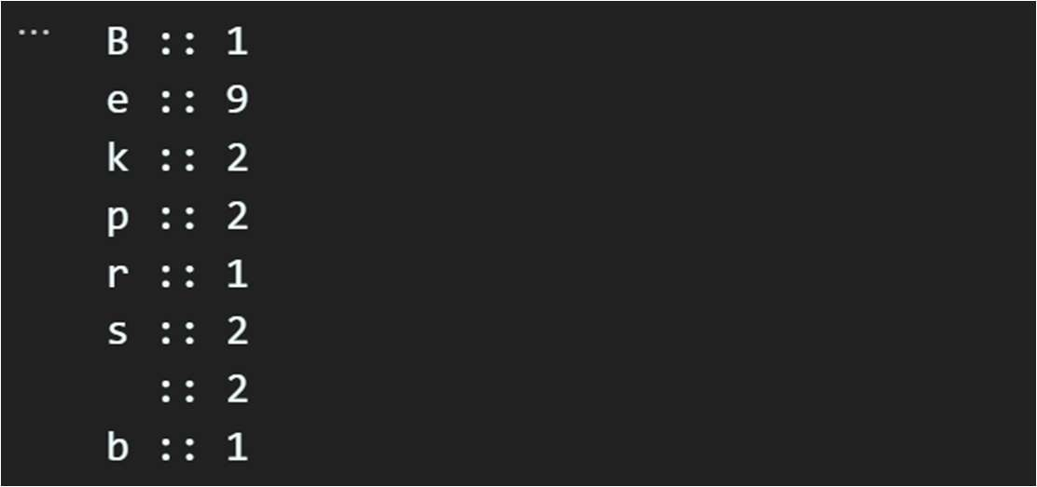

## Exercise 04:

**Problem Name**: Write a Python program to create a tuple with elements from a list and print it.

**Code:**

def maketuple(list): tup=tuple(list) return tup

list=[3,5,2,4,6,7,8,5,34]

tuple=maketuple(list) print(tuple)

**Output:**



## Exercise 05:

**Problem Name**: Write a Python function that takes a list of numbers as input and returns the largest sum of non-adjacent numbers.

**Code:**

def nonadjecntsum(nums): if not nums:

return 0

n = len(nums) if n <= 2:

return max(nums)

max_sum = [0] * n max_sum[0] = nums[0]

max_sum[1] = max(nums[0], nums[1])

for i in range(2, n):

max_sum[i] = max(max_sum[i-1], max_sum[i-2] + nums[i]) return max_sum[n-1]

my_list = [1,3,7,2, 4, 6, 2,9, 5]

result = nonadjecntsum(my_list)

print("Largest sum of non-adjacent numbers:", result)

**Output:**



## Exercise 06:

**Problem Name**: Write a Python program to remove duplicates from a list and return the resultant list.

**Code:**

def dupremove(list): list1=[]

for i in list:

if i not in list1: list1.append(i)

print(f"Duplicates removed list : {list1}")

list = [7,4,7,8,2,0,8,1,0,4,5,6,8,2,9]

dupremove(list)

**Output:**



## Exercise 07:

**Problem Name**: Write a Python program to find the common elements between two lists and return the resultant list.

**Code:**

def common(list1,list2): result=[]

for i in list1: if i in list2:

result.append(i) print(f"common elements : {result}")

list1=[1,4,6,8,0,5]

list2=[7,5,1,9,8,4]

common(list1,list2)

**Output:**



## Exercise 08:

**Problem Name**: Write a Python program to find the first n Fibonacci numbers using recursion.

**Code:**

def fibonacci(n): if n==0:

return elif n==1:

return [0] elif n==2:

return [0,1] else:

seq=fibonacci(n-1) seq.append(seq[-1]+seq[-2]) return seq

n=15

fib=fibonacci(n)

print(f"First {n} Fibonacci numbers : {fib}")

**Output:**



## Exercise 09:

**Problem Name**: Write a Python function to replace all occurrences of a substring in a string.

**Code:**

string = "Good morning teacher." substring="teacher"

replace= "students" rep=string.replace(substring,replace) print(rep)

**Output:**



## Exercise 10:

**Problem Name**: Write a function to add a key-value pair to a dictionary in Python

**Code:**

def addtodic(dictionary,key,value): dictionary[key]=value

return

dictionary={'name':'Tokee',

'roll':'2022'}

key="age" value=23

addtodic(dictionary,key,value) print(dictionary)

**Output:**



## Exercise 11:

**Problem Name**: Write a function to remove a key from a dictionary in Python

**Code:**

def delete(dictionary,key): dictionary.pop(key) return

dictionary={'name':'Tokee' , 'roll':'2022' , 'age':23} key="roll"

delete(dictionary,key) print(dictionary)

**Output:**

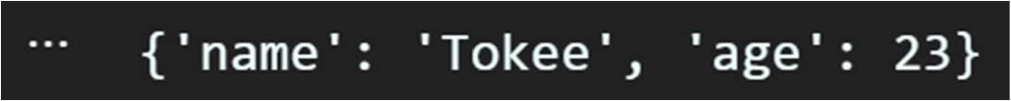

## Exercise 12:

**Problem Name**: Write a function to reverse a list of numbers.

**Code:**

def reverse(list): return list[::-1]

list=[1,2,3,4,5,6,7]

print(f"Reversed list : {reverse(list)}")

**Output:**



## Exercise 13:

**Problem Name**: Write a Python program to find and print the key with the maximum value in a dictionary.

**Code:**

def maxkey(dictionary): max_value = 0 max_key = None

for key, value in dictionary.items(): if value > max_value:

max_value = value max_key = key

return max_key

dictionary = {'a': 10, 'b': 30, 'c': 20} key = maxkey(dictionary)

print(f"Key with maximum value : {key}")

**Output:**



## Exercise 14:

**Problem Name**: Write a Python program to merge two dictionaries and create a new dictionary.

**Code:**

def marge(dict1, dict2): dict={} dict.update(dict1) dict.update(dict2) return dict

dict1 = {'a': 4, 'b': 7, 'c':10}

dict2 = {'x': 3, 'y': 4, 'z':5}

merged_dict = marge(dict1, dict2) print(f"Merged dictionary : {merged_dict}" )

**Output:**



## Exercise 15:

**Problem Name**: Given a list of dictionaries, you want to sort them based on a specific key 'age' in each dictionary. Write a lambda function as the key parameter in the sorted() function to achieve this.

**Code:**

people = [

{'name': 'Alice', 'age': 25},

{'name': 'Bob', 'age': 30},

{'name': 'Charlie', 'age': 20}

]

sort=sorted(people,key=lambda x:x['age']) print(sort)

**Output:**



Institute of Information Technology (IIT)

Jahangirnagar University



# **Lab Report: 04**

Submitted by:

Name: Md. Shakil Hossain

Roll No: 2023

Lab Date: 11-July-2023

Submission Date: 11-Aug-2023

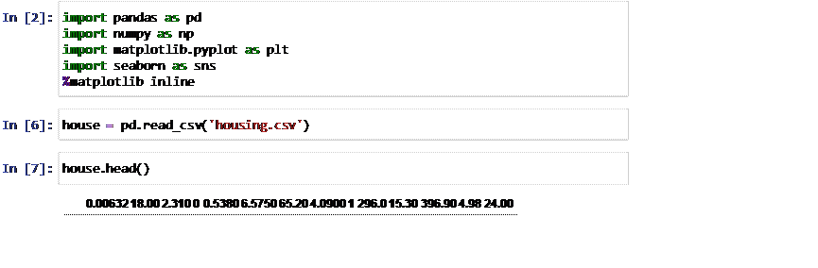

Out[7]:

1. 0.02731 0.00 7.070 0 0.4690 6.4210 78...
2. 0.02729 0.00 7.070 0 0.4690 7.1850 61...
3. 0.03237 0.00 2.180 0 0.4580 6.9980 45...
4. 0.06905 0.00 2.180 0 0.4580 7.1470 54...
5. 0.02985 0.00 2.180 0 0.4580 6.4300 58...

In

[8]:

house

.

columns

Out[8]: Index([' 0.00632 18.00 2.310 0 0.5380 6.5750 65.20 4.0900 1 296.0

15.30 396.90 4.98 24.00'], dtype='object')

Out[20]:

In

[16]:

In

[19]:

In

[20]:

**CRIM**

**ZN**

**INDUS**

**CHAS**

**NOX**

**RM**

**AGE**

**DIS**

**RAD**

**TAX**

**PTRATIO**

**B**

**LSTA**

**0**

0.00632

18.0

2.31

0

0.538

6.575

65.2

4.0900

1

296.0

15.3

396.90

4.9

col

**=**

[

'CRIM'

,

'ZN'

,

'INDUS'

,

'CHAS'

,

'NOX'

,

'RM'

,

'AGE'

,

'DIS'

,

'RAD'

,

'TAX'

,

house_data

**=**

pd

.

read_csv

(

'housing.csv'

,

header

**=**

**None**

,

delimiter

**=**

r"\s+"

,

names

**=**

house_data

.

head

()

|  |  |  |  |  |  |  |  |  |  |  |  |  |  |
| --- | --- | --- | --- | --- | --- | --- | --- | --- | --- | --- | --- | --- | --- |
| **1** | 0.02731 | 0.0 | 7.07 | 0 | 0.469 | 6.421 | 78.9 | 4.9671 | 2 | 242.0 | 17.8 | 396.90 | 9. |
| **2** | 0.02729 | 0.0 | 7.07 | 0 | 0.469 | 7.185 | 61.1 | 4.9671 | 2 | 242.0 | 17.8 | 392.83 | 4.0 |
| **3** | 0.03237 | 0.0 | 2.18 | 0 | 0.458 | 6.998 | 45.8 | 6.0622 | 3 | 222.0 | 18.7 | 394.63 | 2.9 |
| **4** | 0.06905 | 0.0 | 2.18 | 0 | 0.458 | 7.147 | 54.2 | 6.0622 | 3 | 222.0 | 18.7 | 396.90 | 5.3 |

[21]:

house_data

.

info

()

<class 'pandas.core.frame.DataFrame'>

RangeIndex: 506 entries, 0 to 505 Data columns (total 14 columns):

# Column Non-Null Count Dtype

--- ------ -------------- -----

1. CRIM 506 non-null float64
2. ZN 506 non-null float64
3. INDUS 506 non-null float64
4. CHAS 506 non-null int64
5. NOX 506 non-null float64
6. RM 506 non-null float64
7. AGE 506 non-null float64
8. DIS 506 non-null float64
9. RAD 506 non-null int64
10. TAX 506 non-null float64
11. PTRATIO 506 non-null float64
12. B 506 non-null float64
13. LSTAT 506 non-null float64
14. MEDV 506 non-null float64 dtypes: float64(12), int64(2) memory usage: 55.5 KB

Out[22]:

In

[22]:

**CRIM**

**ZN**

**INDUS**

**CHAS**

**NOX**

**RM**

**AGE**

house_data

.

describe

()

**count** 506.000000 506.000000 506.000000 506.000000 506.000000 506.000000 506.000000 506

|  |  |  |  |  |  |  |  |  |
| --- | --- | --- | --- | --- | --- | --- | --- | --- |
| **mean** | 3.613524 | 11.363636 | 11.136779 | 0.069170 | 0.554695 | 6.284634 | 68.574901 | 3 |
| **std** | 8.601545 | 23.322453 | 6.860353 | 0.253994 | 0.115878 | 0.702617 | 28.148861 | 2 |
| **min** | 0.006320 | 0.000000 | 0.460000 | 0.000000 | 0.385000 | 3.561000 | 2.900000 | 1 |
| **25%** | 0.082045 | 0.000000 | 5.190000 | 0.000000 | 0.449000 | 5.885500 | 45.025000 | 2 |
| **50%** | 0.256510 | 0.000000 | 9.690000 | 0.000000 | 0.538000 | 6.208500 | 77.500000 | 3 |
| **75%** | 3.677083 | 12.500000 | 18.100000 | 0.000000 | 0.624000 | 6.623500 | 94.075000 | 5 |
| **max** | 88.976200 | 100.000000 | 27.740000 | 1.000000 | 0.871000 | 8.780000 | 100.000000 | 12 |
|  |  |  |  |  |  |  |  |  |

In

[24]:

house_data

.

columns

Out[24]: Index(['CRIM', 'ZN', 'INDUS', 'CHAS', 'NOX', 'RM', 'AGE', 'DIS', 'RAD', 'TA

X',

'PTRATIO', 'B', 'LSTAT', 'MEDV'], dtype='object')

In

[25]:

house_data

.

index

Out[25]: RangeIndex(start=0, stop=506, step=1)

[27]: house_data.isnull().sum()

Out[27]: CRIM 0 ZN 0

INDUS 0

CHAS 0

NOX 0

RM 0

AGE 0

DIS 0

RAD 0

TAX 0

PTRATIO 0

B 0

LSTAT 0 MEDV 0 dtype: int64

In

[29]:

corr

**=**

house_data

.

corr

()

print

(

house_data

)

CRIM ZN INDUS CHAS NOX RM AGE DIS RAD TAX \

1. 0.00632 18.0 2.31 0 0.538 6.575 65.2 4.0900 1 296.0
2. 0.02731 0.0 7.07 0 0.469 6.421 78.9 4.9671 2 242.0
3. 0.02729 0.0 7.07 0 0.469 7.185 61.1 4.9671 2 242.0
4. 0.03237 0.0 2.18 0 0.458 6.998 45.8 6.0622 3 222.0
5. 0.06905 0.0 2.18 0 0.458 7.147 54.2 6.0622 3 222.0 .. ... ... ... ... ... ... ... ... ... ...
6. 0.06263 0.0 11.93 0 0.573 6.593 69.1 2.4786 1 273.0
7. 0.04527 0.0 11.93 0 0.573 6.120 76.7 2.2875 1 273.0
8. 0.06076 0.0 11.93 0 0.573 6.976 91.0 2.1675 1 273.0
9. 0.10959 0.0 11.93 0 0.573 6.794 89.3 2.3889 1 273.0
10. 0.04741 0.0 11.93 0 0.573 6.030 80.8 2.5050 1 273.0

PTRATIO B LSTAT MEDV 0 15.3 396.90 4.98 24.0

1. 17.8 396.90 9.14 21.6
2. 17.8 392.83 4.03 34.7
3. 18.7 394.63 2.94 33.4
4. 18.7 396.90 5.33 36.2 .. ... ... ... ...
5. 21.0 391.99 9.67 22.4
6. 21.0 396.90 9.08 20.6
7. 21.0 396.90 5.64 23.9
8. 21.0 393.45 6.48 22.0
9. 21.0 396.90 7.88 11.9

[506 rows x 14 columns]

[34]:

plt

.

figure

(

figsize

**=**

(

20

,

15

))

sns

.

heatmap

(

house_data

.

corr

().

abs

()

,

annot

**=**

**True**

)

Out[34]: <Axes: >

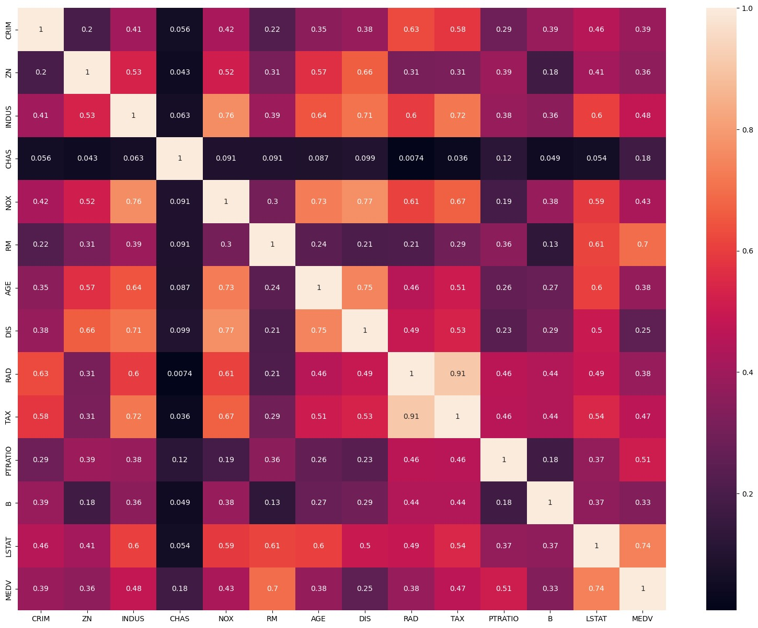

[35]: sns.pairplot(house_data)

Out[35]: <seaborn.axisgrid.PairGrid at 0x289de2236d0>

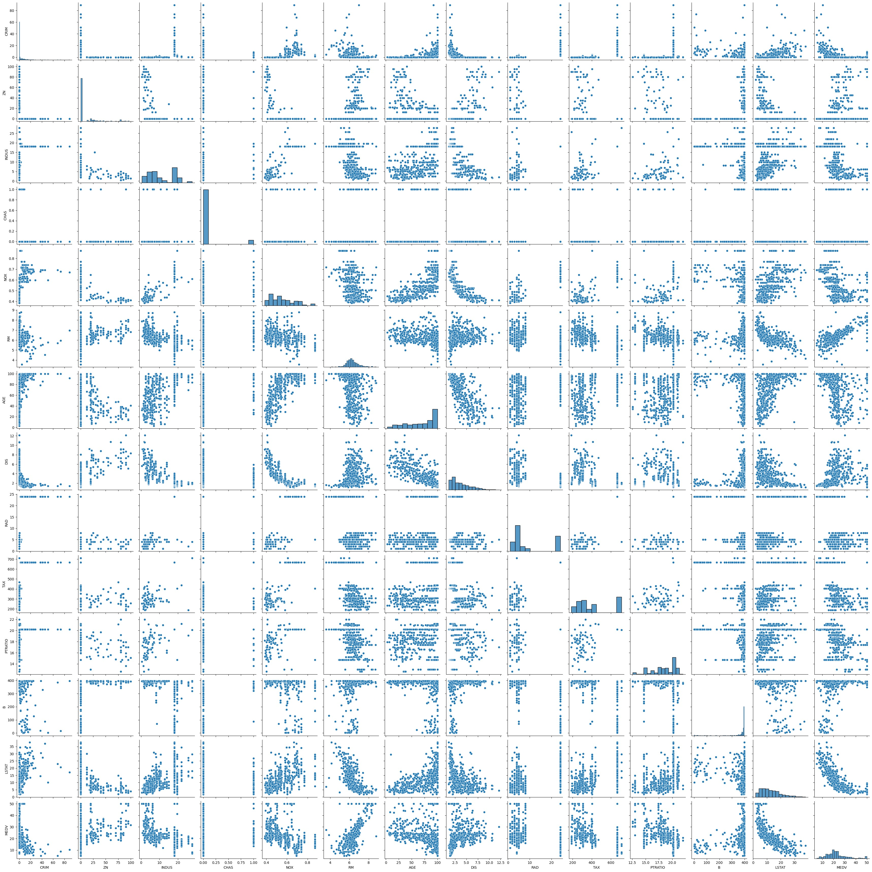

[36]: sns.displot(house_data['LSTAT'])

Out[36]: <seaborn.axisgrid.FacetGrid at 0x289ea07a230>

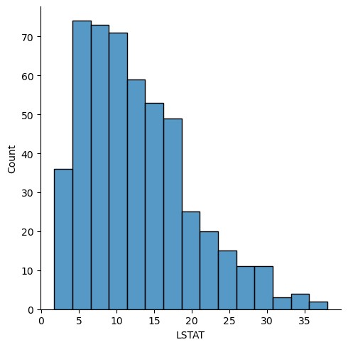

[37]: sns.distplot(house_data['LSTAT'])

C:\Users\User\AppData\Local\Temp\ipykernel_1800\3880656448.py:1: UserWarning:

`distplot` is a deprecated function and will be removed in seaborn v0.14.0.

Please adapt your code to use either `displot` (a figure-level function with similar flexibility) or `histplot` (an axes-level function for histograms).

For a guide to updating your code to use the new functions, please see [https://gist.github.com/mwaskom/de44147ed2974457ad6372750bbe5751 (https://gis](https://gist.github.com/mwaskom/de44147ed2974457ad6372750bbe5751)

[t.github.com/mwaskom/de44147ed2974457ad6372750bbe5751)](https://gist.github.com/mwaskom/de44147ed2974457ad6372750bbe5751)  sns.distplot(house_data['LSTAT'])

Out[37]: <Axes: xlabel='LSTAT', ylabel='Density'>

In

[39]:

In

[41]:

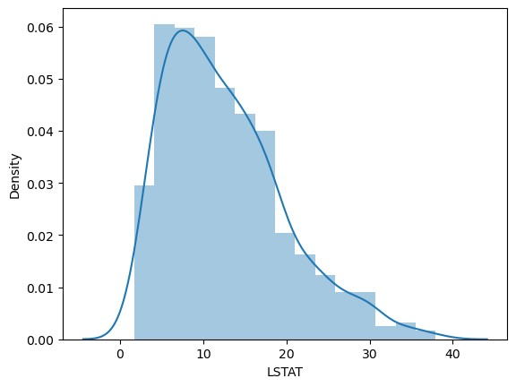

X

**=**

house_data

.

drop

(

'MEDV'

,

axis

**=**

1

)

y

**=**

house_data

[

'MEDV'

]

|  |  |  |  |  |  |  |  |  |  |  |  |  |  |  |
| --- | --- | --- | --- | --- | --- | --- | --- | --- | --- | --- | --- | --- | --- | --- |
| [42]: Out[42]: | X | **CRIM** | **ZN** | **INDUS** | **CHAS** | **NOX** | **RM** | **AGE** | **DIS** | **RAD** | **TAX** | **PTRATIO** | **B** | **LS** |

|  |  |  |  |  |  |  |  |  |  |  |  |  |
| --- | --- | --- | --- | --- | --- | --- | --- | --- | --- | --- | --- | --- |
| **0** | 0.00632 | 18.0 | 2.31 | 0 | 0.538 | 6.575 | 65.2 | 4.0900 | 1 | 296.0 | 15.3 | 396.90 |
| **1** | 0.02731 | 0.0 | 7.07 | 0 | 0.469 | 6.421 | 78.9 | 4.9671 | 2 | 242.0 | 17.8 | 396.90 |
| **2** | 0.02729 | 0.0 | 7.07 | 0 | 0.469 | 7.185 | 61.1 | 4.9671 | 2 | 242.0 | 17.8 | 392.83 |
| **3** | 0.03237 | 0.0 | 2.18 | 0 | 0.458 | 6.998 | 45.8 | 6.0622 | 3 | 222.0 | 18.7 | 394.63 |
| **4** | 0.06905 | 0.0 | 2.18 | 0 | 0.458 | 7.147 | 54.2 | 6.0622 | 3 | 222.0 | 18.7 | 396.90 |
| **...** | ... | ... | ... | ... | ... | ... | ... | ... | ... | ... | ... | ... |
| **501** | 0.06263 | 0.0 | 11.93 | 0 | 0.573 | 6.593 | 69.1 | 2.4786 | 1 | 273.0 | 21.0 | 391.99 |
| **502** | 0.04527 | 0.0 | 11.93 | 0 | 0.573 | 6.120 | 76.7 | 2.2875 | 1 | 273.0 | 21.0 | 396.90 |
| **503** | 0.06076 | 0.0 | 11.93 | 0 | 0.573 | 6.976 | 91.0 | 2.1675 | 1 | 273.0 | 21.0 | 396.90 |
| **504** | 0.10959 | 0.0 | 11.93 | 0 | 0.573 | 6.794 | 89.3 | 2.3889 | 1 | 273.0 | 21.0 | 393.45 |
| **505** | 0.04741 | 0.0 | 11.93 | 0 | 0.573 | 6.030 | 80.8 | 2.5050 | 1 | 273.0 | 21.0 | 396.90 |

In [43]: y

Out[43]: 0 24.0 1 21.6

1. 34.7
2. 33.4
3. 36.2 ... 501 22.4
4. 20.6
5. 23.9
6. 22.0
7. 11.9

In

[44]:

In

[45]:

In

[46]:

Name: MEDV, Length: 506, dtype: float64

**from**

sklearn

.

model_selection

**import**

train_test_split

X_train

,

X_test

,

y_train

,

y_test

**=**

train_test_split

(

X

,

y

,

test_size

**=**

0.3

,

random_stat

**from**

sklearn

.

linear_model

**import**

LinearRegression

model

**=**

LinearRegression

()

[47]: model.fit(X_train,y_train)

Out[47]: LinearRegression()

In a Jupyter environment, please rerun this cell to show the HTML representation or trust the notebook.

On GitHub, the HTML representation is unable to render, please try loading this page with nbviewer.org.

In

[48]:

predictions

**=**

model

.

predict

(

X_test

)

**Model Evaluation**

In

[49]:

print

(

model

.

intercept_

)

31.63108403569186

In

[50]:

print

(

model

.

coef_

)

[-1.33470103e-01 3.58089136e-02 4.95226452e-02 3.11983512e+00 -1.54170609e+01 4.05719923e+00 -1.08208352e-02 -1.38599824e+00 2.42727340e-01 -8.70223437e-03 -9.10685208e-01 1.17941159e-02 -5.47113313e-01]

In [52]: coeff

In

[51]:

Out[52]:

**Coefficient**

**CRIM**

-0.133470

coeff

**=**

pd

.

DataFrame

(

model

.

coef_

,

X

.

columns

,

columns

**=**

[

"Coefficient"

])

**ZN** 0.035809

**INDUS** 0.049523

**CHAS** 3.119835

**NOX** -15.417061

**RM** 4.057199

**AGE** -0.010821

**DIS** -1.385998

**RAD** 0.242727

**TAX** -0.008702

**PTRATIO** -0.910685

**B** 0.011794

**LSTAT** -0.547113

|  |  |  |  |  |  |  |  |  |  |  |
| --- | --- | --- | --- | --- | --- | --- | --- | --- | --- | --- |
| [53]: house_data.head()  Out[53]: **CRIM ZN INDUS** | **CHAS** | **NOX** | **RM** | **AGE** | **DIS** | **RAD** | **TAX** | **PTRATIO** | **B** | **LSTA** |

**0** 0.00632 18.0 2.31 0 0.538 6.575 65.2 4.0900 1 296.0 15.3 396.90 4.9 **1** 0.02731 0.0 7.07 0 0.469 6.421 78.9 4.9671 2 242.0 17.8 396.90 9.

1. 0.02729 0.0 7.07 0 0.469 7.185 61.1 4.9671 2 242.0 17.8 392.83 4.0
2. 0.03237 0.0 2.18 0 0.458 6.998 45.8 6.0622 3 222.0 18.7 394.63 2.9

In

[55]:

**4**

0.06905

0.0

2.18

0

0.458

7.147

54.2

6.0622

3

222.0

18.7

396.90

5.3

model

.

predict

([[

0.00632

,

18.0

,

2.31

,

0

,

0.538

,

6.575

,

65.2

,

4.0900

,

1

,

296.0

,

15.3

,

396.9

C:\Users\User\anaconda3\lib\site-packages\sklearn\base.py:420: UserWarning: X does not have valid feature names, but LinearRegression was fitted with featu re names

warnings.warn(

Out[55]: array([30.08649576])

In [56]: model.predict([[0.06905,0.0,2.18,0,0.458,7.147,54.2,6.0622,3,222.0,18.7,396.90

C:\Users\User\anaconda3\lib\site-packages\sklearn\base.py:420: UserWarning: X does not have valid feature names, but LinearRegression was fitted with featu re names

warnings.warn(

Out[56]: array([28.20837173])

In [57]: model.predict([[0.06905,0.0,2.18,0,0.458,7.147,54.2,6.0622,3,222.0,18.7,396.90

C:\Users\User\anaconda3\lib\site-packages\sklearn\base.py:420: UserWarning: X does not have valid feature names, but LinearRegression was fitted with featu re names

warnings.warn(

Out[57]: array([28.20837173])

[59]: plt.scatter(y_test,predictions)

Out[59]: <matplotlib.collections.PathCollection at 0x289f48bb0d0>

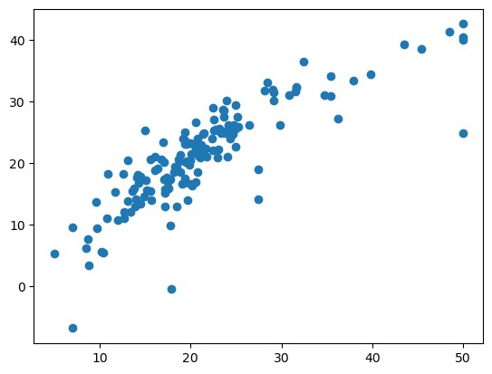

[73]: sns.distplot((y_test**-**predictions),kde **=** **True**,bins **=** 20)

C:\Users\User\AppData\Local\Temp\ipykernel_1800\248592448.py:1: UserWarning:

`distplot` is a deprecated function and will be removed in seaborn v0.14.0.

Please adapt your code to use either `displot` (a figure-level function with similar flexibility) or `histplot` (an axes-level function for histograms).

For a guide to updating your code to use the new functions, please see [https://gist.github.com/mwaskom/de44147ed2974457ad6372750bbe5751 (https://gis](https://gist.github.com/mwaskom/de44147ed2974457ad6372750bbe5751)

[t.github.com/mwaskom/de44147ed2974457ad6372750bbe5751)](https://gist.github.com/mwaskom/de44147ed2974457ad6372750bbe5751)  sns.distplot((y_test-predictions),kde = True,bins = 20)

Out[73]: <Axes: xlabel='MEDV', ylabel='Density'>

In

[60]:

In

[72]:

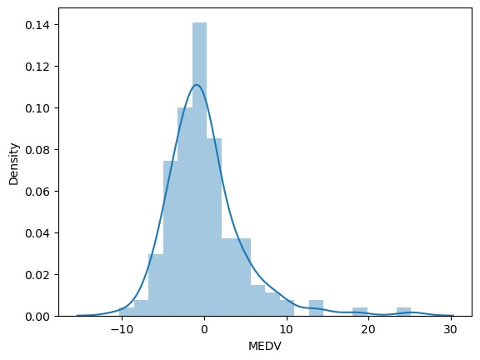

MAE : 3.1627098714574253

MSE : 21.517444231177432

**from**

sklearn

**import**

metrics

print

(

'MAE :'

,

metrics

.

mean_absolute_error

(

y_test

,

predictions

))

print

(

'MSE :'

,

metrics

.

mean_squared_error

(

y_test

,

predictions

))

print

(

'RMSE: '

,

np

.

sqrt

(

metrics

.

mean_squared_error

(

y_test

,

predictions

)))

RMSE: 4.6386

**Institute of Information Technology (IIT)**

Jahangirnagar University



# **Lab Report: 05**

Submitted by:

Name: Md. Shakil Hossain  
Roll No: 2023

Lab Date: 08/08/2023  
Submission Date: 18/08/20

**Lab Report # Day 05**

Apply logistic íegíession techniques to píedict CHD based on the píovided featuíes in the attached Dataset. (Given fíamingham.csv)

**Import Libraries & Read CSV File: Code:**

import numpy as np import pandas as pd

import matplotlib.pyplot as plt import seaborn as sns

import math

%matplotlib inline

data=pd.read_csv("framingham.csv") data.head()

**Output:**

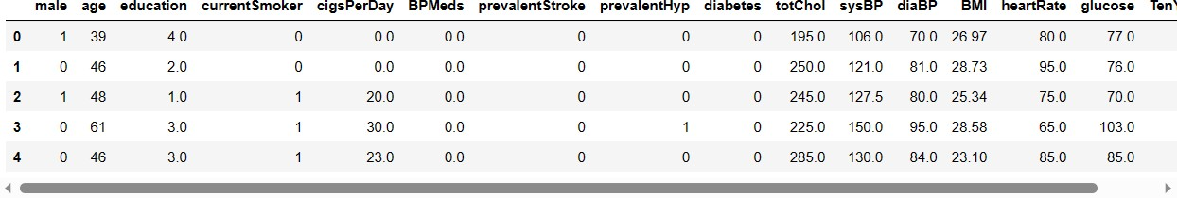

**Code:**

sns.heatmap(data.isnull(),cmap='cividis')

**Output:**

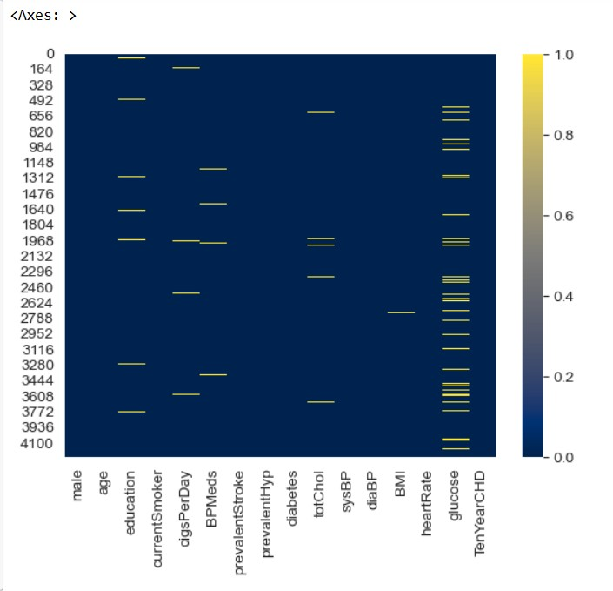

sns.countplot(x='TenYearCHD',hue='education’,data=data)

**Output:**

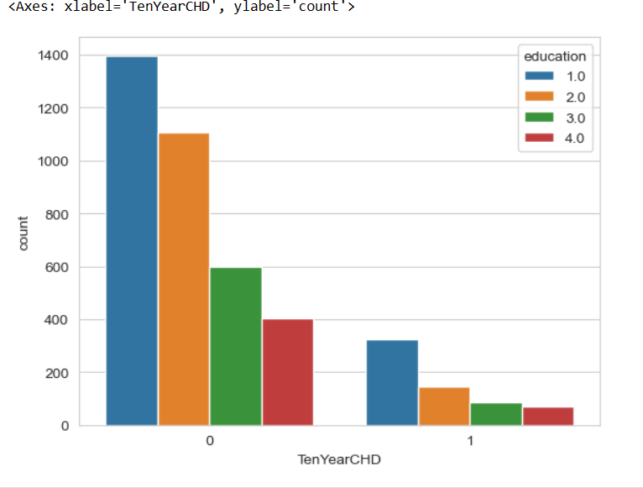

**Code:**

sns.countplot(x='TenYearCHD',hue='male',data=data,palette='RdBu_r')

**Output:**

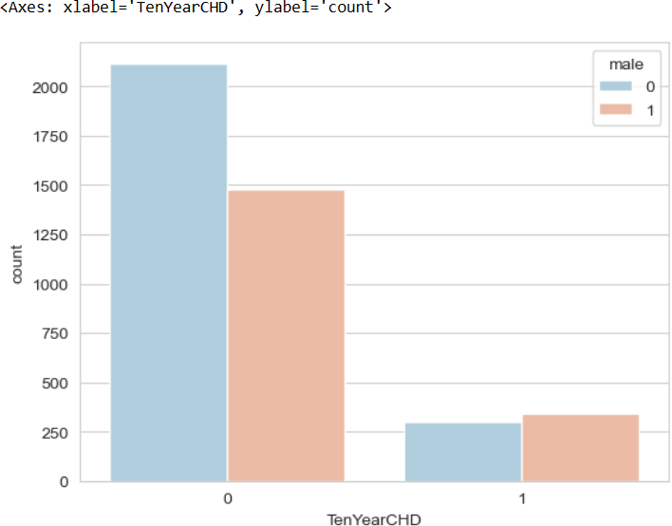

sns.countplot(x='TenYearCHD',hue='currentSmoker',data=data,palette='rocket_r')

**Output:**

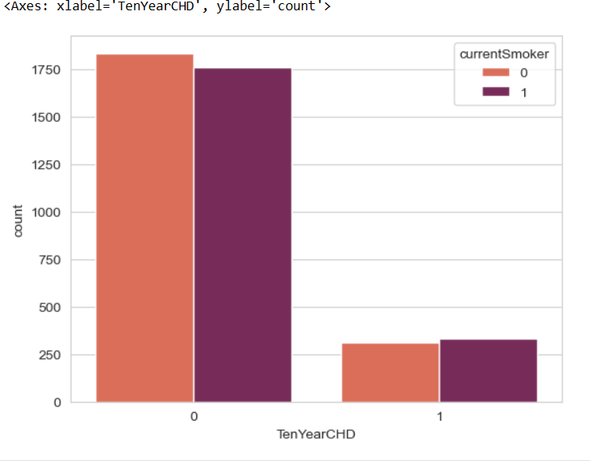

**Output:**

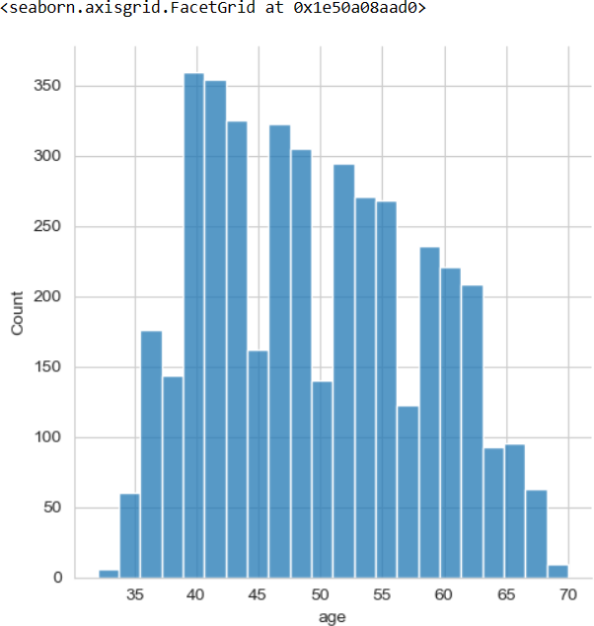

**Code:**

#**Function**

def fill_with_Data(cols): coloum=cols.keys()[0] female=cols[0] male=cols[1]

if pd.isnull(female): if male==1:

return math.ceil(data[data['male']==1][coloum].mean()) elif male==0:

return math.ceil(data[data['male']==0][coloum].mean())

else:

return female

*#***Clean Null Values**

data['education'] = data[['education','male']].apply(fill_with_Data,axis=1) data['cigsPerDay']=data[['cigsPerDay','male']].apply(fill_with_Data,axis=1) data['BPMeds']=data[['BPMeds','male']].apply(fill_with_Data,axis=1) data['totChol']=data[['totChol','male']].apply(fill_with_Data,axis=1) data['BMI']=data[['BMI','male']].apply(fill_with_Data,axis=1) data['heartRate']=data[['heartRate','male']].apply(fill_with_Data,axis=1) data['glucose']=data[['glucose','male']].apply(fill_with_Data,axis=1)

sns.heatmap(data.isnull(),cmap='cividis')

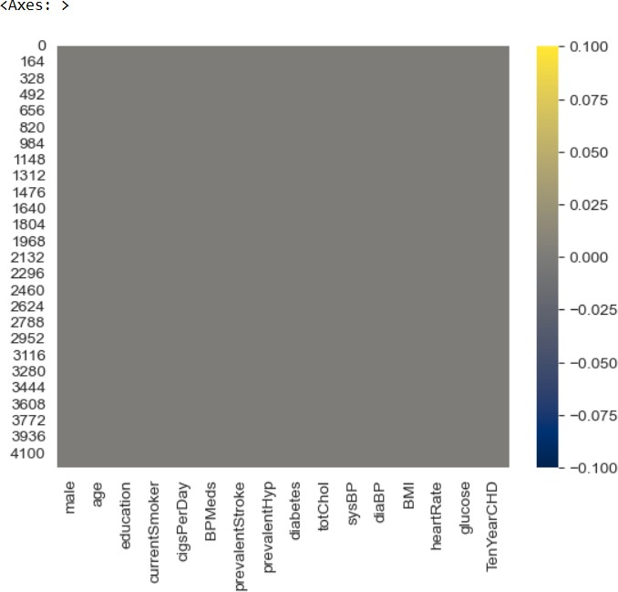

**Building a Logistic Regression Model: Code**

*#* **Train Test Split**

*from sklearn.model_selection import train_test_split x_train,x_test,y_train,y_test=train_test_split(data.drop('TenYearCHD',axis=1), data['TenYearCHD'], test_size=0.3, random_state=101)*

*from sklearn.linear_model import LogisticRegression lrmodel=LogisticRegression(solver='lbfgs',max_iter=1000) lrmodel.fit(x_train,y_train)*

**Output:**

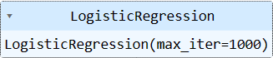

**Code:**

**#Predicting** *predictions=lrmodel.predict(x_test) predictions*

**Output:**



**Evaluation: Code:**

from sklearn.metrics import classification_report print(classification_report(y_test,predictions))

**Output:**

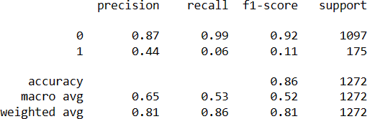

**Institute of Information Technology (IIT)**

Jahangirnagar University



# **Lab Report: 06**

Submitted by:

Name: Md. Shakil Hossain  
Roll No: 2023

Lab Date: 22/08/2023  
Submission Date: 29/08/2023

**K Nearest Neighbors(K-NN)**

**Import Libraries**

In [12]:

**import** pandas **as** pd

**import** numpy **as** np

**import** seaborn **as** sns

**import** matplotlib.pylab **as** plt

**%**matplotlib inline

Get the Data

In [13]:

glass_data **=** pd.read_csv("glass.csv")

In [14]:

glass_data.head()

Out[14]:

|  |  |  |  |  |  |  |  |  |  |
| --- | --- | --- | --- | --- | --- | --- | --- | --- | --- |
| **RI** | **Na** | **Mg** | **Al** | **Si** | **K** | **Ca** | **Ba** | **Fe** | **Type** |
| **0** 1.52101 | 13.64 | 4.49 | 1.10 | 71.78 | 0.06 | 8.75 | 0.0 | 0.0 | 1 |
| **1** 1.51761 | 13.89 | 3.60 | 1.36 | 72.73 | 0.48 | 7.83 | 0.0 | 0.0 | 1 |
| **2** 1.51618 | 13.53 | 3.55 | 1.54 | 72.99 | 0.39 | 7.78 | 0.0 | 0.0 | 1 |
| **3** 1.51766 | 13.21 | 3.69 | 1.29 | 72.61 | 0.57 | 8.22 | 0.0 | 0.0 | 1 |
| **4** 1.51742 | 13.27 | 3.62 | 1.24 | 73.08 | 0.55 | 8.07 | 0.0 | 0.0 | 1 |

In [15]:

glass_data.describe().transpose()

Out[15]:

|  |  |  |  |  |  |  |  |  |
| --- | --- | --- | --- | --- | --- | --- | --- | --- |
|  | **count** | **mean** | **std** | **min** | **25%** | **50%** | **75%** | **max** |
| **RI** | 214.0 | 1.518365 | 0.003037 | 1.51115 | 1.516522 | 1.51768 | 1.519157 | 1.53393 |
| **Na** | 214.0 | 13.407850 | 0.816604 | 10.73000 | 12.907500 | 13.30000 | 13.825000 | 17.38000 |
| **Mg** | 214.0 | 2.684533 | 1.442408 | 0.00000 | 2.115000 | 3.48000 | 3.600000 | 4.49000 |
| **Al** | 214.0 | 1.444907 | 0.499270 | 0.29000 | 1.190000 | 1.36000 | 1.630000 | 3.50000 |
| **Si** | 214.0 | 72.650935 | 0.774546 | 69.81000 | 72.280000 | 72.79000 | 73.087500 | 75.41000 |
| **K** | 214.0 | 0.497056 | 0.652192 | 0.00000 | 0.122500 | 0.55500 | 0.610000 | 6.21000 |
| **Ca** | 214.0 | 8.956963 | 1.423153 | 5.43000 | 8.240000 | 8.60000 | 9.172500 | 16.19000 |
| **Ba** | 214.0 | 0.175047 | 0.497219 | 0.00000 | 0.000000 | 0.00000 | 0.000000 | 3.15000 |
| **Fe** | 214.0 | 0.057009 | 0.097439 | 0.00000 | 0.000000 | 0.00000 | 0.100000 | 0.51000 |
| **Type** | 214.0 | 2.780374 | 2.103739 | 1.00000 | 1.000000 | 2.00000 | 3.000000 | 7.00000 |

In [16]:

glass_data.info()

<class 'pandas.core.frame.DataFrame'> RangeIndex: 214 entries, 0 to 213

Data columns (total 10 columns):

# Column Non-Null Count Dtype

|  |  |  |  |  |  |  |  |
| --- | --- | --- | --- | --- | --- | --- | --- |
| 0 |  | RI |  | 214 | non-null |  | float64 |
| 1 |  | Na |  | 214 | non-null |  | float64 |
| 2 |  | Mg |  | 214 | non-null |  | float64 |
| 3 |  | Al |  | 214 | non-null |  | float64 |
| 4 |  | Si |  | 214 | non-null |  | float64 |
| 5 |  | K |  | 214 | non-null |  | float64 |
| 6 |  | Ca |  | 214 | non-null |  | float64 |
| 7 |  | Ba |  | 214 | non-null |  | float64 |
| 8 |  | Fe |  | 214 | non-null |  | float64 |
| 9 |  | Type |  | 214 | non-null |  | int64 |

dtypes: float64(9), int64(1) memory usage: 16.8 KB

In [17]:

glass_data.isnull().sum()

Out[17]:

|  |  |
| --- | --- |
| RI | 0 |
| Na | 0 |
| Mg | 0 |
| Al | 0 |
| Si | 0 |
| K | 0 |
| Ca | 0 |
| Ba | 0 |
| Fe | 0 |
| Type | 0 |
| dtype: | int64 |

In [18]:

glass_data.hist(figsize**=**(20,20))

Out[18]:

array([[<Axes: title={'center': 'RI'}>, <Axes: title={'center': 'Na'}>,

<Axes: title={'center': 'Mg'}>],

[<Axes: title={'center': 'Al'}>, <Axes: title={'center': 'Si'}>,

<Axes: title={'center': 'K'}>],

[<Axes: title={'center': 'Ca'}>, <Axes: title={'center': 'Ba'}>,

<Axes: title={'center': 'Fe'}>],

[<Axes: title={'center': 'Type'}>, <Axes: >, <Axes: >]], dtype=object)

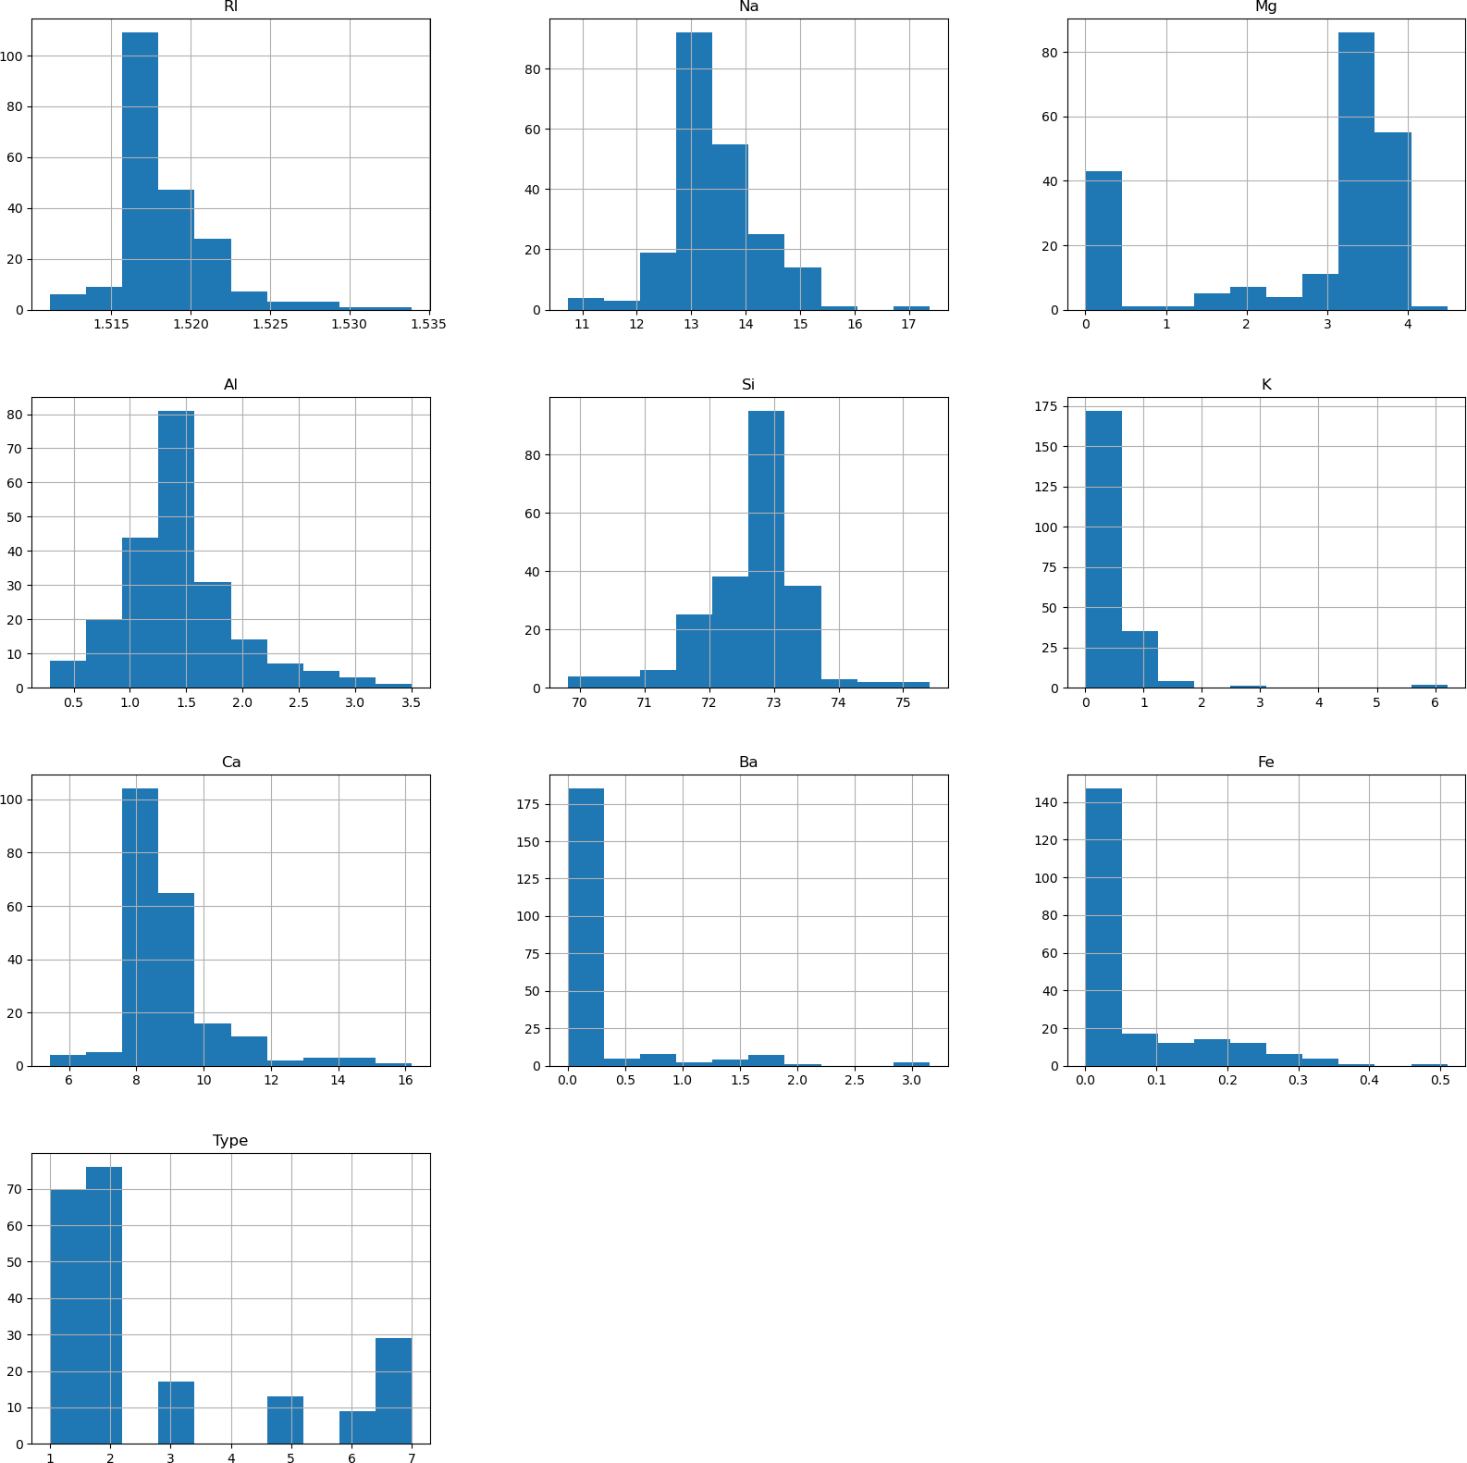

In [19]:

sns.pairplot(glass_data, hue**=**'Type')

Out[19]:

<seaborn.axisgrid.PairGrid at 0x170e0cdc580>

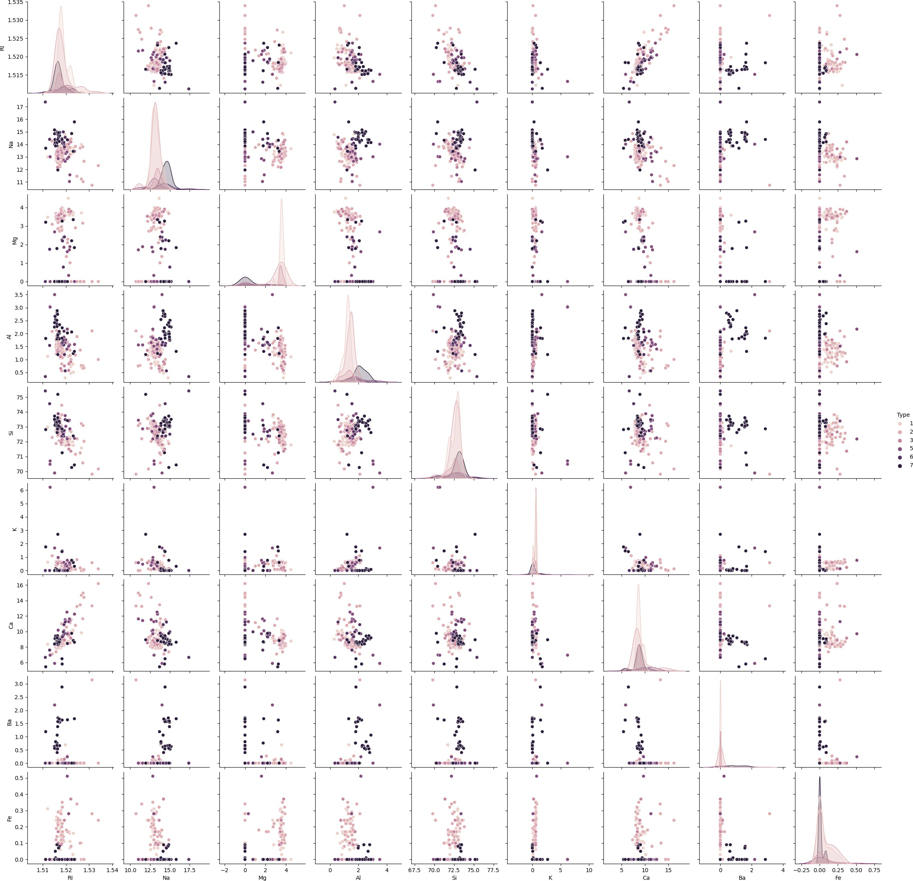

standardize the variables

In [20]:

**from** sklearn.preprocessing **import** StandardScaler

In [21]:

scaler **=** StandardScaler()

In [22]:

X **=** pd.DataFrame(scaler.fit_transform(glass_data.drop(["Type"],axis **=** 1))) y **=** glass_data.Type

|  |  |  |  |  |  |  |  |  |
| --- | --- | --- | --- | --- | --- | --- | --- | --- |
| In [23]: |  | | | | | | | |
| X.head() |  |  |  |  |  |  |  |  |
| Out[23]: |  |  |  |  |  |  |  |  |
| **0** | **1** | **2** | **3** | **4** | **5** | **6** | **7** |  |
| **0** 0.872868 | 0.284953 | 1.254639 | -0.692442 | -1.127082 | -0.671705 | -0.145766 | -0.352877 | -0.5 |
| **1** -0.249333 | 0.591817 | 0.636168 | -0.170460 | 0.102319 | -0.026213 | -0.793734 | -0.352877 | -0.5 |
| **2** -0.721318 | 0.149933 | 0.601422 | 0.190912 | 0.438787 | -0.164533 | -0.828949 | -0.352877 | -0.5 |
| **3** -0.232831 | -0.242853 | 0.698710 | -0.310994 | -0.052974 | 0.112107 | -0.519052 | -0.352877 | -0.5 |
| **4** -0.312045 | -0.169205 | 0.650066 | -0.411375 | 0.555256 | 0.081369 | -0.624699 | -0.352877 | -0.5 |

Train Test Split

In [24]:

**from** sklearn.model_selection **import** train_test_split

In [25]:

X_train, X_test, y_train, y_test **=** train_test_split(X,y,test_size**=**0.30)

Using KNN

In [26]:

**from** sklearn.neighbors **import** KNeighborsClassifier

In [27]:

knn **=** KNeighborsClassifier(n_neighbors**=**1)

In [28]:

knn.fit(X_train,y_train)

Out[28]:

▾

KNeighborsClassifier

KNeighborsClassifier(n_neighbors=1)

In [29]:

pred **=** knn.predict(X_test)

Predictions and Evaluations

In [30]:

**from** sklearn.metrics **import** classification_report,confusion_matrix

In [31]:

print(confusion_matrix(y_test,pred))

|  |  |  |  |  |  |
| --- | --- | --- | --- | --- | --- |
| [[20 | 3 | 1 | 0 | 0 | 0] |
| [ 5 | 20 | 2 | 2 | 0 | 0] |
| [ 3 | 0 | 1 | 0 | 0 | 0] |
| [ 0 | 0 | 0 | 3 | 0 | 0] |
| [ 0 | 0 | 0 | 0 | 1 | 0] |
| [ 0 | 0 | 0 | 0 | 0 | 4]] |

In [32]:

print(classification_report(y_test,pred))

|  |  |  |  |  |
| --- | --- | --- | --- | --- |
|  | precision | recall | f1-score | support |
| 1 | 0.71 | 0.83 | 0.77 | 24 |
| 2 | 0.87 | 0.69 | 0.77 | 29 |
| 3 | 0.25 | 0.25 | 0.25 | 4 |
| 5 | 0.60 | 1.00 | 0.75 | 3 |
| 6 | 1.00 | 1.00 | 1.00 | 1 |
| 7 | 1.00 | 1.00 | 1.00 | 4 |
| accuracy |  |  | 0.75 | 65 |
| macro avg | 0.74 | 0.80 | 0.76 | 65 |
| weighted avg | 0.77 | 0.75 | 0.75 | 65 |

Choosing a K Value

In [33]:

error_rate **=** []

*# Will take some time*

**for** i **in** range(1,40):

knn **=** KNeighborsClassifier(n_neighbors**=**i) knn.fit(X_train,y_train)

pred_i **=** knn.predict(X_test)

error_rate.append(np.mean(pred_i **!=** y_test))

In [34]:

plt.figure(figsize**=**(10,6))

plt.plot(range(1,40),error_rate,color**=**'blue', linestyle**=**'dashed', marker**=**'o', markerfacecolor**=**'red', markersize**=**10)

plt.title('Error Rate vs. K Value') plt.xlabel('K')

plt.ylabel('Error Rate')

Out[34]:

Text(0, 0.5, 'Error Rate')

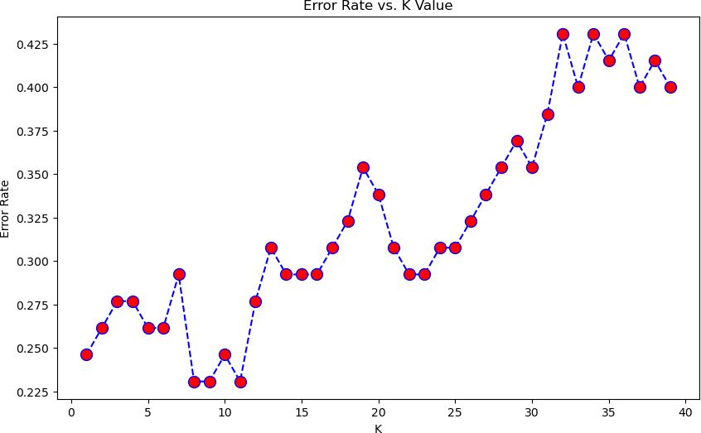

In [35]:

*#Orginal K=1*

knn **=** KNeighborsClassifier(n_neighbors**=**1)

knn.fit(X_train,y_train)

pred **=** knn.predict(X_test)

print('WITH k=1') print('\n')

print(confusion_matrix(y_test,pred)) print('\n')

print(classification_report(y_test,pred))

|  |  |  |  |  |  |
| --- | --- | --- | --- | --- | --- |
| WITH | k=1 |  | | | |
| [[20 | 3 | 1 | 0 | 0 | 0] |
| [ 5 | 20 | 2 | 2 | 0 | 0] |
| [ 3 | 0 | 1 | 0 | 0 | 0] |
| [ 0 | 0 | 0 | 3 | 0 | 0] |
| [ 0 | 0 | 0 | 0 | 1 | 0] |
| [ 0 | 0 | 0 | 0 | 0 | 4]] |

|  |  |  |  |  |
| --- | --- | --- | --- | --- |
|  | precision | recall | f1-score | support |
| 1 | 0.71 | 0.83 | 0.77 | 24 |
| 2 | 0.87 | 0.69 | 0.77 | 29 |
| 3 | 0.25 | 0.25 | 0.25 | 4 |
| 5 | 0.60 | 1.00 | 0.75 | 3 |
| 6 | 1.00 | 1.00 | 1.00 | 1 |
| 7 | 1.00 | 1.00 | 1.00 | 4 |
| accuracy |  |  | 0.75 | 65 |
| macro avg | 0.74 | 0.80 | 0.76 | 65 |
| weighted avg | 0.77 | 0.75 | 0.75 | 65 |

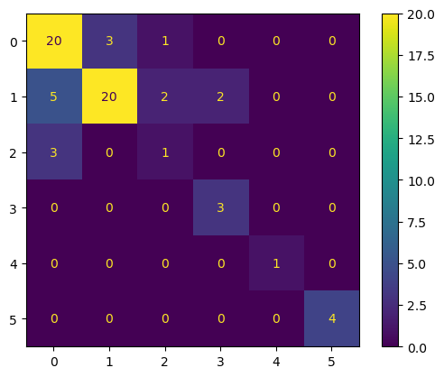In [36]

**from** sklearn.metrics **import** ConfusionMatrixDisplay

**import** matplotlib.pyplot **as** plt

conf_matrix **=** confusion_matrix(y_test, pred)

vis **=** ConfusionMatrixDisplay(confusion_matrix **=** conf_matrix,display_labels **=** [**True**,**False** vis.plot()

plt.grid(**False**) plt.show()

*#Now With K=17*

In [37]:

knn **=** KNeighborsClassifier(n_neighbors**=**17)

knn.fit(X_train,y_train)

pred **=** knn.predict(X_test)

print('WITH k=17') print('\n')

print(confusion_matrix(y_test,pred)) print('\n')

print(classification_report(y_test,pred))

|  |  |  |  |  |  |
| --- | --- | --- | --- | --- | --- |
| WITH | k=17 |  | | | |
| [[21 | 3 | 0 | 0 | 0 | 0] |
| [ 7 | 20 | 0 | 0 | 2 | 0] |
| [ 4 | 0 | 0 | 0 | 0 | 0] |
| [ 1 | 1 | 0 | 1 | 0 | 0] |
| [ 1 | 0 | 0 | 0 | 0 | 0] |
| [ 0 | 1 | 0 | 0 | 0 | 3]] |



|  |  |  |  |  |
| --- | --- | --- | --- | --- |
|  | precision | recall | f1-score | support |
| 1 | 0.62 | 0.88 | 0.72 | 24 |
| 2 | 0.80 | 0.69 | 0.74 | 29 |
| 3 | 0.00 | 0.00 | 0.00 | 4 |
| 5 | 1.00 | 0.33 | 0.50 | 3 |
| 6 | 0.00 | 0.00 | 0.00 | 1 |
| 7 | 1.00 | 0.75 | 0.86 | 4 |

In [38]:

**from** sklearn.metrics **import** ConfusionMatrixDisplay

**import** matplotlib.pyplot **as** plt

conf_matrix **=** confusion_matrix(y_test, pred)

vis **=** ConfusionMatrixDisplay(confusion_matrix **=** conf_matrix,display_labels **=** [**True**,**False** vis.plot()

plt.grid(**False**) plt.show()

In [ ]:

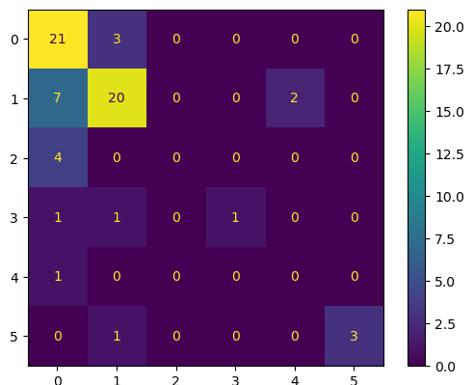

**Institute of Information Technology (IIT)**

Jahangirnagar University



# **Lab Report: 07**

Submitted by:

Name: Md. Shakil Hossain  
Roll No: 2023

Lab Date: 28/08/2023  
Submission Date: 01/09/2023

Support Vector Machines with Python

**Import Libraries**

In [1]:

**import** pandas **as** pd

**import** numpy **as** np

**import** matplotlib.pyplot **as** plt

**import** seaborn **as** sns

**%**matplotlib inline

**Get the Data**

In [2]:

IRIS **=** pd.read_csv('IRIS.csv')

In [3]:

IRIS.keys()

Out[3]:

Index(['sepal_length', 'sepal_width', 'petal_length', 'petal_width', 'species'],

dtype='object')

In [4]:

IRIS.head()

Out[4]:

|  |  |  |  |  |
| --- | --- | --- | --- | --- |
| **sepal_length** | **sepal_width** | **petal_length** | **petal_width** | **species** |
| **0** 5.1 | 3.5 | 1.4 | 0.2 | Iris-setosa |
| **1** 4.9 | 3.0 | 1.4 | 0.2 | Iris-setosa |
| **2** 4.7 | 3.2 | 1.3 | 0.2 | Iris-setosa |
| **3** 4.6 | 3.1 | 1.5 | 0.2 | Iris-setosa |
| **4** 5.0 | 3.6 | 1.4 | 0.2 | Iris-setosa |

|  |  |
| --- | --- |
| 0 | 0.2 |
| 1 | 0.2 |
| 2 | 0.2 |
| 3 | 0.2 |
| 4 | 0.2 |

...

145 2.3

146 1.9

147 2.0

148 2.3

149 1.8

Name: petal_width, Length: 150, dtype: float64

In [6]:

print(IRIS['species'])

1. Iris-setosa
2. Iris-setosa
3. Iris-setosa
4. Iris-setosa
5. Iris-setosa

...

1. Iris-virginica
2. Iris-virginica
3. Iris-virginica
4. Iris-virginica
5. Iris-virginica

Name: species, Length: 150, dtype: object

Out[7]:

<seaborn.axisgrid.PairGrid at 0x1ef17977df0>

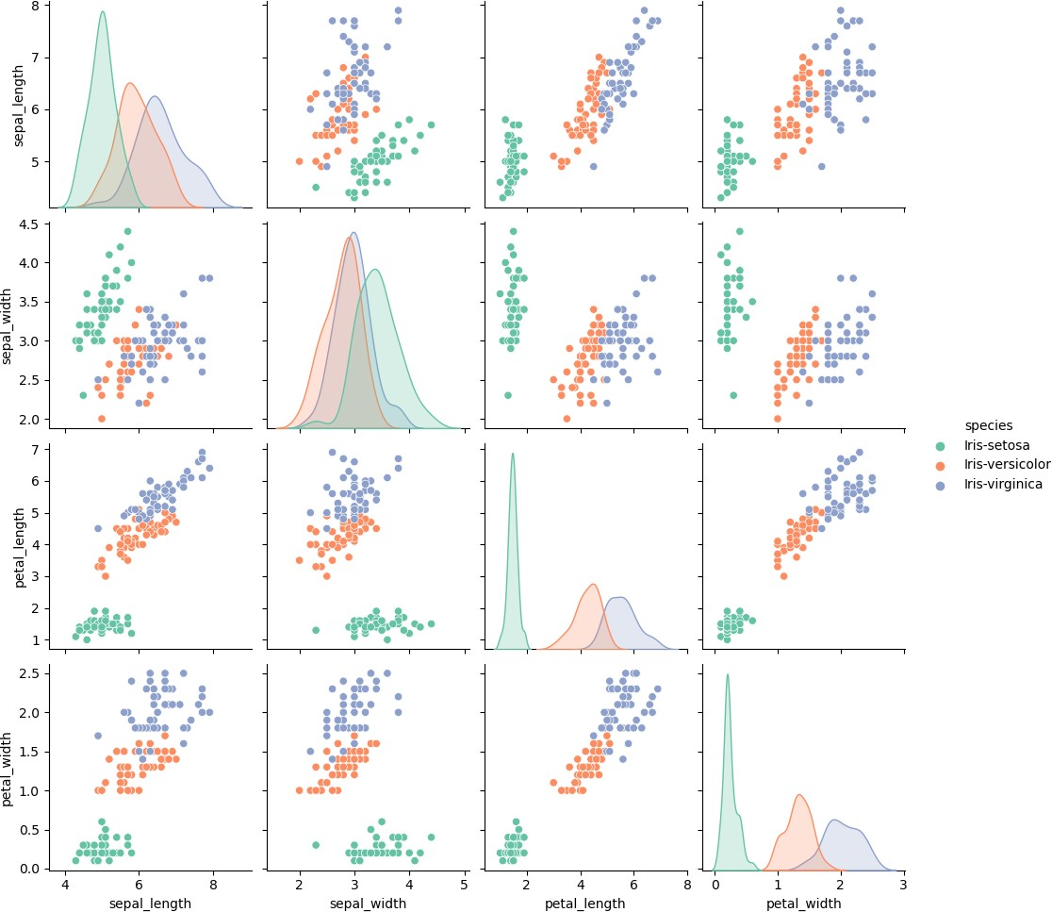

**Set up DataFrame**

In [8]:

df_IRIS **=** pd.DataFrame(IRIS['sepal_length'],columns**=**IRIS['species']) df_IRIS.info()

<class 'pandas.core.frame.DataFrame'> Index: 0 entries

Columns: 150 entries, Iris-setosa to Iris-virginica dtypes: object(150)

memory usage: 0.0+ bytes

IRIS['petal_width']

Out[9]:

|  |  |
| --- | --- |
| 0 | 0.2 |
| 1 | 0.2 |
| 2 | 0.2 |
| 3 | 0.2 |
| 4 | 0.2 |

...

145 2.3

146 1.9

147 2.0

148 2.3

149 1.8

Name: petal_width, Length: 150, dtype: float64

In [10]:

df_petal_width **=** pd.DataFrame(IRIS['petal_width'],columns**=**['IRIS'])

**Train Test Split**

In [11]:

**from** sklearn.model_selection **import** train_test_split

In [12]:

x**=**IRIS.iloc[:,:**-**1]

y**=**IRIS.iloc[:,4]

x_train,x_test, y_train, y_test**=**train_test_split(x,y,test_size**=**0.30)

In [13]:

**from** sklearn.svm **import** SVC model**=**SVC()

In [14]:

model.fit(x_train, y_train)

Out[14]:

▾ SVC

SVC()

pred**=**model.predict(x_test)

**Model Evaluation**

In [16]:

**from** sklearn.metrics **import** classification_report, confusion_matrix

In [17]:

print(confusion_matrix(y_test,pred))

|  |  |  |
| --- | --- | --- |
| [[20 | 0 | 0] |
| [ 0 | 12 | 0] |
| [ 0 | 2 | 11]] |

In [18]:

print(classification_report(y_test, pred))

|  |  |  |  |  |
| --- | --- | --- | --- | --- |
| precision | recall | f1-score | support |  |
| Iris-setosa 1.00 | 1.00 | 1.00 | 20 |
| Iris-versicolor 0.86 | 1.00 | 0.92 | 12 |
| Iris-virginica 1.00 | 0.85 | 0.92 | 13 |
| accuracy |  | 0.96 | 45 |
| macro avg 0.95 | 0.95 | 0.95 | 45 |
| weighted avg 0.96 | 0.96 | 0.96 | 45 |
| **Gridsearch** |  |  |  |
| In [19]: |  |  |  |
| param_grid **=** {'C': [0.1,1,5, | 10, 50, | 100, 1000], | 'gamma': | [10,1,0.1,0.01,0.001,0.0001], |
| In [20]: |  |  |  |  |

**from** sklearn.model_selection **import** GridSearchCV

In [21]:

grid **=** GridSearchCV(SVC(),param_grid,refit**=True**,verbose**=**5)



me= 0.0s

[CV 1/5] END ....C=10, gamma=0.1, kernel=linear;, score=1.000 total ti me= 0.0s

[CV 2/5] END ....C=10, gamma=0.1, kernel=linear;, score=0.952 total ti me= 0.0s

[CV 3/5] END ....C=10, gamma=0.1, kernel=linear;, score=1.000 total ti me= 0.0s

[CV 4/5] END ....C=10, gamma=0.1, kernel=linear;, score=0.905 total ti me= 0.0s

[CV 5/5] END ....C=10, gamma=0.1, kernel=linear;, score=1.000 total ti me= 0.0s

[CV 1/5] END ......C=10, gamma=0.01, kernel=rbf;, score=0.952 total ti me= 0.0s

[CV 2/5] END ......C=10, gamma=0.01, kernel=rbf;, score=0.952 total ti me= 0.0s

[CV 3/5] END ......C=10, gamma=0.01, kernel=rbf;, score=1.000 total ti me= 0.0s

[CV 4/5] END ......C=10, gamma=0.01, kernel=rbf;, score=0.905 total ti me= 0.0s

grid.fit(x_train,y_train)

In [23]:

grid.best_params_

Out[23]:

{'C': 5, 'gamma': 10, 'kernel': 'linear'}

In [24]:

grid.best_estimator_

Out[24]:

▾

SVC

SVC(C=5, gamma=10, kernel='linear')

In [25]:

grid_predictions **=** grid.predict(x_test)

In [26]:

print(confusion_matrix(y_test,grid_predictions))

|  |  |  |
| --- | --- | --- |
| [[20 | 0 | 0] |
| [ 0 | 11 | 1] |
| [ 0 | 0 | 13]] |

print(classification_report(y_test,grid_predictions))

|  |  |  |  |  |
| --- | --- | --- | --- | --- |
|  | precision | recall | f1-score | support |
| Iris-setosa | 1.00 | 1.00 | 1.00 | 20 |
| Iris-versicolor | 1.00 | 0.92 | 0.96 | 12 |
| Iris-virginica | 0.93 | 1.00 | 0.96 | 13 |
| accuracy |  |  | 0.98 | 45 |
| macro avg | 0.98 | 0.97 | 0.97 | 45 |
| weighted avg | 0.98 | 0.98 | 0.98 | 45 |

In [ ]:

**Institute of Information Technology (IIT)**

Jahangirnagar University



# **Lab Report: 08**

Submitted by:

Name: Md. Shakil Hossain  
Roll No: 2023

Lab Date: 28/08/2023  
Submission Date: 03/09/2023

K-Means Clustering

K-Means Clustering is an Unsupervised Learning algorithm, which groups the unlabeled dataset into different clusters. Here K defines the number of pre-defined clusters that need to be created in the process, as if K=2, there will be two clusters, and for K=3, there will be three clusters, and so on.

“It is an iterative algorithm that divides the unlabeled dataset into k different clusters in such a way that each dataset belongs only one group that has similar properties.”

It allows us to cluster the data into different groups and a convenient way to discover the categories of groups in the unlabeled dataset on its own without the need for any training.

It is a centroid-based algorithm, where each cluster is associated with a centroid. The main aim of this algorithm is to minimize the sum of distances between the data point and their corresponding clusters.

**The k-means clustering algorithm mainly performs two tasks:**

* Determines the best value for K center points or centroids by an iterative process.
* Assigns each data point to its closest k-center. Those data points which are near to the particular k-center, create a cluster.

Hence each cluster has datapoints with some commonalities, and it is away from other clusters.

The below diagram explains the working of the K-means Clustering Algorithm:

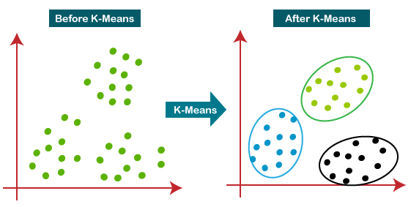

**How does the K-Means Algorithm Work?**

The working of the K-Means algorithm is explained in the below steps:

Step-1: Select the number K to decide the number of clusters.

Step-2: Select random K points or centroids. (It can be other from the input dataset).

Step-3: Assign each data point to their closest centroid, which will form the predefined K clusters.

Step-4: Calculate the variance and place a new centroid of each cluster.

Step-5: Repeat the third steps, which means reassign each datapoint to the new closest centroid of each cluster.

Step-6: If any reassignment occurs, then go to step-4 else go to FINISH.

Step-7: The model is ready.

When using the Kmeans algorithm under normal circumstances, it is because you don't have labels. In this case we will use the labels to try to get an idea of how well the algorithm performed, but you won't usually do this for Kmeans, so the classification report and confusion matrix at the end of this project, don't truly make sense in a real world setting!.

**Connectivity-based clustering**

* Distance based
* E.g., Hierarchical clustering

**Centroid-based clustering**

* Represents each cluster by a single mean vector
* E.g., k-means algorithm

**Distribution-based clustering**

* Modeled using statistical distributions
* E.g., Multivariate normal distributions used by the expectation-maximization algorithm.

**Density-based clustering**

* Defines clusters as connected dense regions in the data space.
* E.g., DBSCAN

**Source of the data**

https://www.kaggle.com/datasets/karthikthallam/college-data/code

**Import libraries**

In [1]:

**import** numpy **as** np *# linear algebra*

**import** pandas **as** pd *# data processing, CSV file I/O (e.g. pd.read_csv)*

**import** matplotlib.pyplot **as** plt *# for data visualization*

**import** seaborn **as** sns *# for statistical data visualization*

**%**matplotlib inline

In [3]:

df **=** pd.read_csv('../Resource/College.csv')

Exploratory data analysis

In [4]:

df.shape

Out[4]:

(777, 19)

In [5]:

df.head()

Out[5]:

**0**

|  |  |  |  |  |  |  |  |  |  |
| --- | --- | --- | --- | --- | --- | --- | --- | --- | --- |
| **Unnamed: Private** | | | **Apps** | **Accept** | **Enroll** | **Top10perc** | **Top25perc** | **F.Undergrad** | **P.Undergr** |
| Abilene  **0** Christian Yes University | | | 1660 | 1232 | 721 | 23 | 52 | 2885 | 5 |
| **1** Adelphi Yes | | | 2186 | 1924 | 512 | 16 | 29 | 2683 | 12 |
| **2** Adrian Yes | | | 1428 | 1097 | 336 | 22 | 50 | 1036 |  |
| Agnes  **3** Scott Yes | | | 417 | 349 | 137 | 60 | 89 | 510 |  |
|  | College |  |  |  |  |  |  |  |  |
| **4** | Alaska Pacific | Yes | 193 | 146 | 55 | 16 | 44 | 249 | 8 |
|  | University |  |  |  |  |  |  |  |  |

In [6]:

df.info()

<class 'pandas.core.frame.DataFrame'> RangeIndex: 777 entries, 0 to 776

Data columns (total 19 columns):

# Column Non-Null Count Dtype

|  |  |  |  |  |  |  |  |
| --- | --- | --- | --- | --- | --- | --- | --- |
| 0 |  | Unnamed: | 0 | 777 | non-null |  | object |
| 1 |  | Private |  | 777 | non-null |  | object |
| 2 |  | Apps |  | 777 | non-null |  | int64 |
| 3 |  | Accept |  | 777 | non-null |  | int64 |
| 4 |  | Enroll |  | 777 | non-null |  | int64 |
| 5 | Top10perc | | | 777 | non-null | int64 | |
| 6 | Top25perc | | | 777 | non-null | int64 | |
| 7 | F.Undergrad | | | 777 | non-null | int64 | |
| 8 | P.Undergrad | | | 777 | non-null | int64 | |
| 9 | Outstate | | | 777 | non-null | int64 | |
| 10 | Room.Board | | | 777 | non-null | int64 | |
| 11 | Books | | | 777 | non-null | int64 | |
| 12 | Personal | | | 777 | non-null | int64 | |
| 13 | PhD | | | 777 | non-null | int64 | |
| 14 | Terminal | | | 777 | non-null | int64 | |
| 15 | S.F.Ratio | | | 777 | non-null | float64 | |
| 16 | perc.alumni | | | 777 | non-null | int64 | |
| 17 | Expend | | | 777 | non-null | int64 | |
| 18 | Grad.Rate | | | 777 | non-null | int64 | |

dtypes: float64(1), int64(16), object(2) memory usage: 115.5+ KB

In [7]:

df.isnull().sum()

Out[7]:

Unnamed: 0 0

Private 0

Apps 0

Accept 0

Enroll 0

Top10perc 0

Top25perc 0

F.Undergrad 0

P.Undergrad 0

Outstate 0

Room.Board 0

Books 0

Personal 0

PhD 0

Terminal 0

S.F.Ratio 0

perc.alumni 0

Expend 0

Grad.Rate 0

dtype: int64

In [8]:

df.drop(['S.F.Ratio', 'perc.alumni', 'Expend', 'Grad.Rate'], axis**=**1, inplace**=True**)

In [9]:

df.info()

<class 'pandas.core.frame.DataFrame'> RangeIndex: 777 entries, 0 to 776

Data columns (total 15 columns):

# Column Non-Null Count Dtype

|  |  |  |  |  |  |  |  |
| --- | --- | --- | --- | --- | --- | --- | --- |
| 0 |  | Unnamed: | 0 | 777 | non-null |  | object |
| 1 |  | Private |  | 777 | non-null |  | object |
| 2 |  | Apps |  | 777 | non-null |  | int64 |
| 3 |  | Accept |  | 777 | non-null |  | int64 |
| 4 |  | Enroll |  | 777 | non-null |  | int64 |
| 5 | Top10perc | | | 777 | non-null | int64 | |
| 6 | Top25perc | | | 777 | non-null | int64 | |
| 7 | F.Undergrad | | | 777 | non-null | int64 | |
| 8 | P.Undergrad | | | 777 | non-null | int64 | |
| 9 | Outstate | | | 777 | non-null | int64 | |
| 10 | Room.Board | | | 777 | non-null | int64 | |
| 11 | Books | | | 777 | non-null | int64 | |
| 12 | Personal | | | 777 | non-null | int64 | |
| 13 | PhD | | | 777 | non-null | int64 | |
| 14 | Terminal | | | 777 | non-null | int64 | |

dtypes: int64(13), object(2) memory usage: 91.2+ KB

In [10]:

df.describe()

|  |  |  |  |  |  |  |
| --- | --- | --- | --- | --- | --- | --- |
| Out[10]: |  | | | | | |
| **Apps** | **Accept** | **Enroll** | **Top10perc** | **Top25perc** | **F.Undergrad** | **P.U** |
| **count** 777.000000 | 777.000000 | 777.000000 | 777.000000 | 777.000000 | 777.000000 | 7 |
| **mean** 3001.638353 | 2018.804376 | 779.972973 | 27.558559 | 55.796654 | 3699.907336 | 8 |
| **std** 3870.201484 | 2451.113971 | 929.176190 | 17.640364 | 19.804778 | 4850.420531 | 15 |
| **min** 81.000000 | 72.000000 | 35.000000 | 1.000000 | 9.000000 | 139.000000 |  |
| **25%** 776.000000 | 604.000000 | 242.000000 | 15.000000 | 41.000000 | 992.000000 |  |
| **50%** 1558.000000 | 1110.000000 | 434.000000 | 23.000000 | 54.000000 | 1707.000000 | 3 |
| **75%** 3624.000000 | 2424.000000 | 902.000000 | 35.000000 | 69.000000 | 4005.000000 | 9 |
| **max** 48094.000000 | 26330.000000 | 6392.000000 | 96.000000 | 100.000000 | 31643.000000 | 218 |

In [11]:



Out[11]:

array(['Abilene Christian University', 'Adelphi University', 'Adrian College', 'Agnes Scott College',

'Alaska Pacific University', 'Albertson College',

'Albertus Magnus College', 'Albion College', 'Albright Colleg

e',

'Alderson-Broaddus College', 'Alfred University',

'Allegheny College', 'Allentown Coll. of St. Francis de Sales', 'Alma College', 'Alverno College',

'American International College', 'Amherst College', 'Anderson University', 'Andrews University',

'Angelo State University', 'Antioch University',

'Appalachian State University', 'Aquinas College', 'Arizona State University Main campus',

'Arkansas College (Lyon College)', 'Arkansas Tech University', 'Assumption College', 'Auburn University-Main Campus',

'Augsburg College', 'Augustana College IL', 'Augustana Colleg

e',

'Austin College', 'Averett College', 'Baker University',

df['Unnamed: 0'].unique()

In [12]:

len(df['Unnamed: 0'].unique())

Out[12]:

777

In [13]:

df['Private'].unique()

Out[13]:

array(['Yes', 'No'], dtype=object)

In [14]:

len(df['Private'].unique())

Out[14]:

2

In [15]:

df.drop(['Private'], axis**=**1, inplace**=True**)

In [16]:

df.info()

<class 'pandas.core.frame.DataFrame'> RangeIndex: 777 entries, 0 to 776

Data columns (total 14 columns):

# Column Non-Null Count Dtype

|  |  |  |  |  |  |  |  |
| --- | --- | --- | --- | --- | --- | --- | --- |
| 0 |  | Unnamed: | 0 | 777 | non-null |  | object |
| 1 |  | Apps |  | 777 | non-null |  | int64 |
| 2 |  | Accept |  | 777 | non-null |  | int64 |
| 3 |  | Enroll |  | 777 | non-null |  | int64 |
| 4 | Top10perc | | | 777 | non-null | int64 | |
| 5 | Top25perc | | | 777 | non-null | int64 | |
| 6 | F.Undergrad | | | 777 | non-null | int64 | |
| 7 | P.Undergrad | | | 777 | non-null | int64 | |
| 8 | Outstate | | | 777 | non-null | int64 | |
| 9 | Room.Board | | | 777 | non-null | int64 | |
| 10 | Books | | | 777 | non-null | int64 | |
| 11 | Personal | | | 777 | non-null | int64 | |
| 12 | PhD | | | 777 | non-null | int64 | |
| 13 | Terminal | | | 777 | non-null | int64 | |

dtypes: int64(13), object(1) memory usage: 85.1+ KB

In [17]:

df.head()

Out[17]:

**0**

|  |  |  |  |  |  |  |  |  |  |
| --- | --- | --- | --- | --- | --- | --- | --- | --- | --- |
| **Unnamed: Apps** | | | **Accept** | **Enroll** | **Top10perc** | **Top25perc** | **F.Undergrad** | **P.Undergrad** | **Outs** |
| Abilene  **0** Christian 1660 University | | | 1232 | 721 | 23 | 52 | 2885 | 537 | 7 |
| **1** Adelphi 2186 | | | 1924 | 512 | 16 | 29 | 2683 | 1227 | 12 |
| **2** Adrian 1428 | | | 1097 | 336 | 22 | 50 | 1036 | 99 | 11 |
| Agnes  **3** Scott 417 | | | 349 | 137 | 60 | 89 | 510 | 63 | 12 |
|  | College |  |  |  |  |  |  |  |  |
| **4** | Alaska Pacific | 193 | 146 | 55 | 16 | 44 | 249 | 869 | 7 |
|  | University |  |  |  |  |  |  |  |  |

University College

In [18]:

plt.figure(figsize**=**(10,6))

plt.scatter(df['Apps'],df['Enroll']) plt.xlabel('Number of Apps')

plt.ylabel('number of Enroll') plt.title('LIVE Download')

Out[18]:

Text(0.5, 1.0, 'LIVE Download')

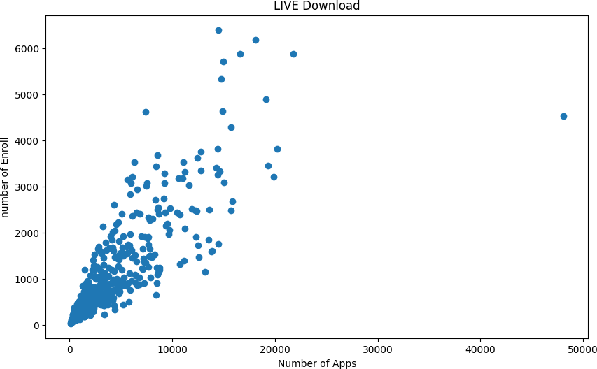

**Declare feature vector and target variable**

In [19]:

df.head(2)

Out[19]:

**0**

|  |  |  |  |  |  |  |  |
| --- | --- | --- | --- | --- | --- | --- | --- |
| **Unnamed: Apps** | **Accept** | **Enroll** | **Top10perc** | **Top25perc** | **F.Undergrad** | **P.Undergrad** | **Outs** |
| Abilene  **0** Christian 1660 University | 1232 | 721 | 23 | 52 | 2885 | 537 | 7 |
| **1** Adelphi 2186 | 1924 | 512 | 16 | 29 | 2683 | 1227 | 12 |

University

**Convert categorical variable into integers**

In [20]:

**from** sklearn.preprocessing **import** LabelEncoder le **=** LabelEncoder()

df['Unnamed: 0'] **=** le.fit_transform(df['Unnamed: 0'])

In [22]:

y**=**df

cols **=** y.columns

**from** sklearn.preprocessing **import** MinMaxScaler ms **=** MinMaxScaler()

y **=** ms.fit_transform(y)

y **=** pd.DataFrame(y, columns**=**[cols])

In [23]:

X **=** y.values

X[:5] *# Show first 5 records only*

Out[23]:

array([[0. , 0.03288693, 0.04417701, 0.10791254, 0.23157895,

|  |  |  |  |  |
| --- | --- | --- | --- | --- |
| 0.47252747, | 0.08716353, | 0.02454774, | 0.26342975, | 0.23959647, |
| 0.15775401, | 0.29770992, | 0.65263158, | 0.71052632], |  |
| [0.00128866, | 0.04384229, | 0.07053089, | 0.07503539, | 0.15789474, |
| 0.21978022, | 0.08075165, | 0.05614839, | 0.51342975, | 0.73612863, |
| 0.29144385, | 0.19083969, | 0.22105263, | 0.07894737], |  |
| [0.00257732, | 0.0280549 , | 0.03903572, | 0.04734938, | 0.22105263, |
| 0.45054945, | 0.02847257, | 0.00448821, | 0.46022727, | 0.31052963, |
| 0.13547237, | 0.13969466, | 0.47368421, | 0.55263158], |  |
| [0.00386598, | 0.0069981 , | 0.01054917, | 0.0160453 , | 0.62105263, |
| 0.87912088, | 0.01177628, | 0.00283948, | 0.54855372, | 0.57849937, |
| 0.15775401, | 0.09541985, | 0.88421053, | 0.96052632], |  |
| [0.00515464, | 0.0023327 , | 0.00281819, | 0.00314614, | 0.15789474, |
| 0.38461538, | 0.00349162, | 0.03975269, | 0.2696281 , | 0.36885246, |

0.31372549, 0.19083969, 0.71578947, 0.63157895]])

**Feature Scaling**

In [25]:

**from** sklearn.cluster **import** KMeans clustering_score **=** []

**for** i **in** range(1, 11):

kmeans **=** KMeans(n_clusters **=** i, init **=** 'random', random_state **=** 42) kmeans.fit(X)

clustering_score.append(kmeans.inertia_)

plt.figure(figsize**=**(10,6))

plt.plot(range(1, 11), clustering_score)

plt.scatter(4,clustering_score[3], s **=** 200, c **=** 'red', marker**=**'*') plt.title('The Elbow Method')

plt.xlabel('No. of Clusters') plt.ylabel('Clustering Score') plt.show()

c:\Users\USER\AppData\Local\Programs\Python\Python39\lib\site-packages\sk learn\cluster\_kmeans.py:1412: FutureWarning: The default value of `n_ini t` will change from 10 to 'auto' in 1.4. Set the value of `n_init` explic itly to suppress the warning

super()._check_params_vs_input(X, default_n_init=10)

c:\Users\USER\AppData\Local\Programs\Python\Python39\lib\site-packages\sk learn\cluster\_kmeans.py:1412: FutureWarning: The default value of `n_ini t` will change from 10 to 'auto' in 1.4. Set the value of `n_init` explic itly to suppress the warning

super()._check_params_vs_input(X, default_n_init=10)

c:\Users\USER\AppData\Local\Programs\Python\Python39\lib\site-packages\sk learn\cluster\_kmeans.py:1412: FutureWarning: The default value of `n_ini t` will change from 10 to 'auto' in 1.4. Set the value of `n_init` explic itly to suppress the warning

super()._check_params_vs_input(X, default_n_init=10)

c:\Users\USER\AppData\Local\Programs\Python\Python39\lib\site-packages\sk learn\cluster\_kmeans.py:1412: FutureWarning: The default value of `n_ini t` will change from 10 to 'auto' in 1.4. Set the value of `n_init` explic itly to suppress the warning

super()._check_params_vs_input(X, default_n_init=10)

c:\Users\USER\AppData\Local\Programs\Python\Python39\lib\site-packages\sk learn\cluster\_kmeans.py:1412: FutureWarning: The default value of `n_ini t` will change from 10 to 'auto' in 1.4. Set the value of `n_init` explic itly to suppress the warning

super()._check_params_vs_input(X, default_n_init=10)

c:\Users\USER\AppData\Local\Programs\Python\Python39\lib\site-packages\sk learn\cluster\_kmeans.py:1412: FutureWarning: The default value of `n_ini t` will change from 10 to 'auto' in 1.4. Set the value of `n_init` explic itly to suppress the warning

super()._check_params_vs_input(X, default_n_init=10)

c:\Users\USER\AppData\Local\Programs\Python\Python39\lib\site-packages\sk learn\cluster\_kmeans.py:1412: FutureWarning: The default value of `n_ini t` will change from 10 to 'auto' in 1.4. Set the value of `n_init` explic itly to suppress the warning

super()._check_params_vs_input(X, default_n_init=10)

c:\Users\USER\AppData\Local\Programs\Python\Python39\lib\site-packages\sk learn\cluster\_kmeans.py:1412: FutureWarning: The default value of `n_ini t` will change from 10 to 'auto' in 1.4. Set the value of `n_init` explic itly to suppress the warning

super()._check_params_vs_input(X, default_n_init=10)

c:\Users\USER\AppData\Local\Programs\Python\Python39\lib\site-packages\sk learn\cluster\_kmeans.py:1412: FutureWarning: The default value of `n_ini t` will change from 10 to 'auto' in 1.4. Set the value of `n_init` explic itly to suppress the warning

super()._check_params_vs_input(X, default_n_init=10)

c:\Users\USER\AppData\Local\Programs\Python\Python39\lib\site-packages\sk learn\cluster\_kmeans.py:1412: FutureWarning: The default value of `n_ini t` will change from 10 to 'auto' in 1.4. Set the value of `n_init` explic itly to suppress the warning

super()._check_params_vs_input(X, default_n_init=10)

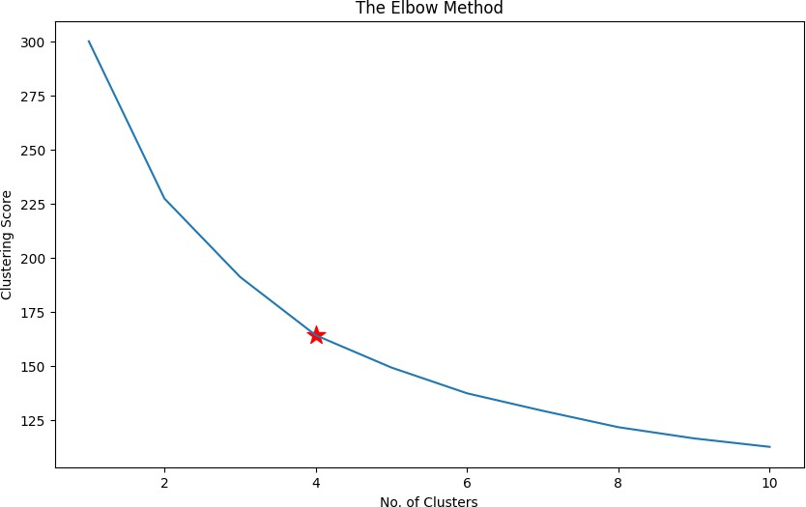

**K-Means model with five clusters**

In [26]:

kmeans**=** KMeans(n_clusters **=** 5, random_state **=** 42)

*# Compute k-means clustering*

kmeans.fit(X)

*# Compute cluster centers and predict cluster index for each sample.*

pred **=** kmeans.predict(X) pred

c:\Users\USER\AppData\Local\Programs\Python\Python39\lib\site-packages\sk learn\cluster\_kmeans.py:1412: FutureWarning: The default value of `n_ini t` will change from 10 to 'auto' in 1.4. Set the value of `n_init` explic itly to suppress the warning

super()._check_params_vs_input(X, default_n_init=10)

|  |  |  |  |  |  |  |  |  |  |  |  |  |  |  |  |  |  |  |  |  |  |
| --- | --- | --- | --- | --- | --- | --- | --- | --- | --- | --- | --- | --- | --- | --- | --- | --- | --- | --- | --- | --- | --- |
| Out[26]: |  | | | | | | | | | | | | | | | | | | | | |
| array([0, | 0, | 0, | 2, | 0, | 0, | 2, | 2, | 2, | 0, | 2, | 2, | 2, | 2, | 0, | 0, | 2, | 0, | 0, | 0, | 0, | 0, |
| 0, | 4, | 2, | 0, | 2, | 4, | 0, | 2, | 0, | 2, | 0, | 0, | 0, | 0, | 2, | 2, | 0, | 0, | 2, | 0, | 0, | 0, |
| 2, | 0, | 0, | 0, | 2, | 0, | 0, | 0, | 0, | 0, | 2, | 0, | 0, | 0, | 0, | 2, | 2, | 4, | 0, | 2, | 2, | 0, |
| 0, | 0, | 0, | 4, | 2, | 2, | 2, | 0, | 2, | 0, | 0, | 0, | 2, | 0, | 0, | 0, | 0, | 0, | 0, | 0, | 2, | 2, |
| 0, | 0, | 0, | 2, | 0, | 0, | 2, | 0, | 2, | 0, | 0, | 2, | 0, | 2, | 0, | 0, | 0, | 0, | 2, | 2, | 2, | 0, |
| 2, | 0, | 0, | 0, | 2, | 2, | 0, | 2, | 4, | 0, | 2, | 0, | 2, | 2, | 0, | 0, | 0, | 0, | 0, | 0, | 2, | 0, |
| 0, | 0, | 0, | 0, | 0, | 2, | 2, | 2, | 2, | 4, | 0, | 0, | 2, | 0, | 0, | 0, | 0, | 2, | 0, | 2, | 2, | 0, |
| 0, | 0, | 0, | 0, | 2, | 2, | 0, | 0, | 2, | 2, | 2, | 0, | 0, | 0, | 0, | 0, | 0, | 2, | 2, | 2, | 2, | 2, |
| 4, | 0, | 0, | 0, | 0, | 0, | 0, | 0, | 2, | 2, | 2, | 0, | 0, | 0, | 2, | 2, | 0, | 2, | 0, | 0, | 2, | 0, |
| 0, | 0, | 2, | 4, | 0, | 4, | 0, | 2, | 0, | 0, | 0, | 0, | 0, | 0, | 0, | 2, | 0, | 0, | 0, | 0, | 2, | 2, |
| 0, | 2, | 2, | 0, | 0, | 2, | 0, | 2, | 0, | 0, | 2, | 0, | 0, | 0, | 0, | 0, | 0, | 2, | 0, | 2, | 2, | 0, |
| 2, | 2, | 2, | 0, | 2, | 0, | 0, | 2, | 2, | 2, | 0, | 2, | 2, | 2, | 2, | 2, | 2, | 2, | 2, | 2, | 0, | 0, |
| 0, | 0, | 0, | 0, | 2, | 4, | 2, | 0, | 0, | 0, | 4, | 0, | 0, | 4, | 2, | 4, | 0, | 0, | 0, | 2, | 2, | 0, |
| 0, | 2, | 4, | 0, | 0, | 0, | 2, | 0, | 0, | 0, | 2, | 0, | 2, | 2, | 0, | 2, | 0, | 0, | 0, | 0, | 2, | 2, |
| 2, | 2, | 2, | 0, | 0, | 2, | 0, | 0, | 0, | 0, | 2, | 0, | 0, | 0, | 0, | 0, | 4, | 0, | 2, | 2, | 2, | 2, |
| 2, | 0, | 0, | 0, | 2, | 0, | 0, | 0, | 2, | 2, | 0, | 0, | 2, | 3, | 2, | 4, | 2, | 2, | 3, | 0, | 3, | 2, |
| 0, | 0, | 1, | 0, | 0, | 0, | 0, | 2, | 0, | 3, | 3, | 0, | 3, | 4, | 4, | 2, | 0, | 3, | 0, | 3, | 2, | 0, |
| 3, | 3, | 0, | 0, | 0, | 2, | 3, | 3, | 3, | 3, | 0, | 3, | 2, | 3, | 0, | 0, | 1, | 0, | 0, | 0, | 0, | 3, |
| 3, | 2, | 2, | 0, | 2, | 3, | 3, | 3, | 2, | 2, | 2, | 1, | 0, | 1, | 3, | 3, | 4, | 3, | 1, | 3, | 3, | 3, |
| 4, | 4, | 4, | 3, | 3, | 3, | 1, | 3, | 0, | 3, | 1, | 1, | 1, | 2, | 4, | 1, | 3, | 3, | 4, | 3, | 3, | 3, |
| 1, | 1, | 3, | 1, | 3, | 4, | 1, | 3, | 3, | 3, | 3, | 3, | 3, | 1, | 3, | 3, | 1, | 3, | 3, | 1, | 3, | 4, |
| 3, | 3, | 3, | 3, | 3, | 3, | 1, | 1, | 3, | 1, | 1, | 3, | 1, | 3, | 1, | 3, | 3, | 3, | 1, | 3, | 3, | 4, |
| 1, | 3, | 3, | 3, | 3, | 3, | 3, | 3, | 3, | 3, | 3, | 1, | 3, | 1, | 1, | 3, | 3, | 1, | 1, | 3, | 3, | 1, |
| 3, | 3, | 3, | 3, | 4, | 1, | 1, | 3, | 3, | 1, | 1, | 1, | 3, | 3, | 3, | 3, | 3, | 3, | 1, | 3, | 3, | 1, |
| 1, | 3, | 3, | 3, | 3, | 3, | 1, | 3, | 4, | 3, | 3, | 3, | 1, | 3, | 1, | 3, | 3, | 3, | 3, | 1, | 3, | 1, |
| 1, | 3, | 3, | 3, | 3, | 3, | 1, | 1, | 3, | 1, | 4, | 4, | 4, | 4, | 3, | 3, | 3, | 3, | 3, | 1, | 3, | 3, |
| 3, | 3, | 1, | 1, | 1, | 3, | 3, | 3, | 3, | 4, | 3, | 3, | 3, | 4, | 3, | 3, | 3, | 3, | 1, | 1, | 3, | 1, |
| 1, | 3, | 1, | 1, | 3, | 3, | 3, | 1, | 3, | 3, | 4, | 4, | 1, | 4, | 3, | 1, | 4, | 4, | 1, | 3, | 4, | 1, |
| 3, | 3, | 3, | 4, | 4, | 3, | 4, | 4, | 4, | 3, | 4, | 3, | 4, | 3, | 3, | 3, | 3, | 4, | 4, | 3, | 1, | 4, |
| 3, | 1, | 4, | 3, | 4, | 1, | 3, | 3, | 3, | 4, | 3, | 4, | 3, | 4, | 4, | 3, | 3, | 4, | 1, | 4, | 3, | 4, |
| 1, | 4, | 4, | 1, | 4, | 1, | 1, | 4, | 1, | 1, | 1, | 1, | 3, | 1, | 3, | 4, | 4, | 1, | 3, | 3, | 3, | 3, |
| 1, | 4, | 3, | 4, | 4, | 3, | 1, | 1, | 1, | 4, | 1, | 1, | 4, | 3, | 3, | 3, | 3, | 3, | 4, | 4, | 3, | 3, |
| 1, | 3, | 3, | 1, | 1, | 1, | 1, | 4, | 3, | 4, | 3, | 3, | 3, | 3, | 1, | 3, | 1, | 3, | 3, | 3, | 1, | 1, |
| 1, | 4, | 1, | 3, | 3, | 3, | 3, | 1, | 1, | 3, | 3, | 1, | 3, | 3, | 3, | 3, | 1, | 4, | 3, | 3, | 4, | 3, |
| 3, | 3, | 3, | 1, | 1, | 1, | 3, | 1, | 1, | 1, | 1, | 3, | 1, | 3, | 3, | 1, | 3, | 3, | 3, | 3, | 3, | 1, |
| 1, | 1, | 3, | 3, | 3, | 1, | 3]) |  |  |  |  |  |  |  |  |  |  |  |  |  |  |  |

In [27]:

df['Cluster'] **=** pd.DataFrame(pred, columns**=**['cluster'] )

print('Number of data points in each cluster= \n', df['Cluster'].value_counts()) df

Number of data points in each cluster=

|  |  |  |
| --- | --- | --- |
|  | 0 | 226 |
| 3 |  | 219 |
| 2 |  | 143 |
| 1 |  | 111 |
| 4 |  | 78 |

Name: Cluster, dtype: int64

Out[27]:

**Unnamed:**

**0**

**Apps Accept Enroll Top10perc Top25perc F.Undergrad P.Undergrad O**

**0** 0 1660 1232 721 23 52 2885 537

**1** 1 2186 1924 512 16 29 2683 1227

**2** 2 1428 1097 336 22 50 1036 99

**3** 3 417 349 137 60 89 510 63

**4** 4 193 146 55 16 44 249 869

**...** ... ... ... ... ... ... ... ...

**772** 772 2197 1515 543 4 26 3089 2029

**773** 773 1959 1805 695 24 47 2849 1107

**774** 774 2097 1915 695 34 61 2793 166

**775** 775 10705 2453 1317 95 99 5217 83

**776** 776 2989 1855 691 28 63 2988 1726

777 rows × 15 columns

**Vizualization**

In [28]:

plt.figure(figsize**=**(10,6))

plt.scatter(kmeans.cluster_centers_[:,1], kmeans.cluster_centers_[:, 2],s **=**100, c **=** 'red

plt.xlabel('num_reactions') plt.ylabel('num_comments') plt.legend()

plt.title('Live selling')

|  |  |  |  |  |  |  |  |  |  |  |
| --- | --- | --- | --- | --- | --- | --- | --- | --- | --- | --- |
| plt.scatter(X[pred | **==** | 0, | 3], | X[pred | **==** | 0, | 2], | c | **=** | 'brown', label **=** 'Cluster 0') |
| plt.scatter(X[pred | **==** | 1, | 3], | X[pred | **==** | 1, | 2], | c | **=** | 'green', label **=** 'Cluster 1') |
| plt.scatter(X[pred | **==** | 2, | 3], | X[pred | **==** | 2, | 2], | c | **=** | 'blue', label **=** 'Cluster 2') |
| plt.scatter(X[pred | **==** | 3, | 3], | X[pred | **==** | 3, | 2], | c | **=** | 'purple', label **=** 'Cluster 3') |
| plt.scatter(X[pred | **==** | 4, | 3], | X[pred | **==** | 4, | 2], | c | **=** | 'orange', label **=** 'Cluster 4') |

Out[28]:

Text(0.5, 1.0, 'Live selling')

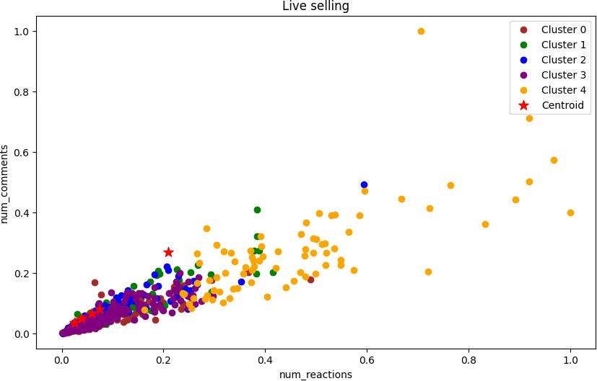

**K-Means model parameters study**

In [29]:

labels1 **=** kmeans.labels_

centroids1 **=** kmeans.cluster_centers_ labels1

Out[29]:

|  |  |  |  |  |  |  |  |  |  |  |  |  |  |  |  |  |  |  |  |  |  |
| --- | --- | --- | --- | --- | --- | --- | --- | --- | --- | --- | --- | --- | --- | --- | --- | --- | --- | --- | --- | --- | --- |
| array([0, | 0, | 0, | 2, | 0, | 0, | 2, | 2, | 2, | 0, | 2, | 2, | 2, | 2, | 0, | 0, | 2, | 0, | 0, | 0, | 0, | 0, |
| 0, | 4, | 2, | 0, | 2, | 4, | 0, | 2, | 0, | 2, | 0, | 0, | 0, | 0, | 2, | 2, | 0, | 0, | 2, | 0, | 0, | 0, |
| 2, | 0, | 0, | 0, | 2, | 0, | 0, | 0, | 0, | 0, | 2, | 0, | 0, | 0, | 0, | 2, | 2, | 4, | 0, | 2, | 2, | 0, |
| 0, | 0, | 0, | 4, | 2, | 2, | 2, | 0, | 2, | 0, | 0, | 0, | 2, | 0, | 0, | 0, | 0, | 0, | 0, | 0, | 2, | 2, |
| 0, | 0, | 0, | 2, | 0, | 0, | 2, | 0, | 2, | 0, | 0, | 2, | 0, | 2, | 0, | 0, | 0, | 0, | 2, | 2, | 2, | 0, |
| 2, | 0, | 0, | 0, | 2, | 2, | 0, | 2, | 4, | 0, | 2, | 0, | 2, | 2, | 0, | 0, | 0, | 0, | 0, | 0, | 2, | 0, |
| 0, | 0, | 0, | 0, | 0, | 2, | 2, | 2, | 2, | 4, | 0, | 0, | 2, | 0, | 0, | 0, | 0, | 2, | 0, | 2, | 2, | 0, |
| 0, | 0, | 0, | 0, | 2, | 2, | 0, | 0, | 2, | 2, | 2, | 0, | 0, | 0, | 0, | 0, | 0, | 2, | 2, | 2, | 2, | 2, |
| 4, | 0, | 0, | 0, | 0, | 0, | 0, | 0, | 2, | 2, | 2, | 0, | 0, | 0, | 2, | 2, | 0, | 2, | 0, | 0, | 2, | 0, |
| 0, | 0, | 2, | 4, | 0, | 4, | 0, | 2, | 0, | 0, | 0, | 0, | 0, | 0, | 0, | 2, | 0, | 0, | 0, | 0, | 2, | 2, |
| 0, | 2, | 2, | 0, | 0, | 2, | 0, | 2, | 0, | 0, | 2, | 0, | 0, | 0, | 0, | 0, | 0, | 2, | 0, | 2, | 2, | 0, |
| 2, | 2, | 2, | 0, | 2, | 0, | 0, | 2, | 2, | 2, | 0, | 2, | 2, | 2, | 2, | 2, | 2, | 2, | 2, | 2, | 0, | 0, |
| 0, | 0, | 0, | 0, | 2, | 4, | 2, | 0, | 0, | 0, | 4, | 0, | 0, | 4, | 2, | 4, | 0, | 0, | 0, | 2, | 2, | 0, |
| 0, | 2, | 4, | 0, | 0, | 0, | 2, | 0, | 0, | 0, | 2, | 0, | 2, | 2, | 0, | 2, | 0, | 0, | 0, | 0, | 2, | 2, |
| 2, | 2, | 2, | 0, | 0, | 2, | 0, | 0, | 0, | 0, | 2, | 0, | 0, | 0, | 0, | 0, | 4, | 0, | 2, | 2, | 2, | 2, |
| 2, | 0, | 0, | 0, | 2, | 0, | 0, | 0, | 2, | 2, | 0, | 0, | 2, | 3, | 2, | 4, | 2, | 2, | 3, | 0, | 3, | 2, |
| 0, | 0, | 1, | 0, | 0, | 0, | 0, | 2, | 0, | 3, | 3, | 0, | 3, | 4, | 4, | 2, | 0, | 3, | 0, | 3, | 2, | 0, |
| 3, | 3, | 0, | 0, | 0, | 2, | 3, | 3, | 3, | 3, | 0, | 3, | 2, | 3, | 0, | 0, | 1, | 0, | 0, | 0, | 0, | 3, |
| 3, | 2, | 2, | 0, | 2, | 3, | 3, | 3, | 2, | 2, | 2, | 1, | 0, | 1, | 3, | 3, | 4, | 3, | 1, | 3, | 3, | 3, |
| 4, | 4, | 4, | 3, | 3, | 3, | 1, | 3, | 0, | 3, | 1, | 1, | 1, | 2, | 4, | 1, | 3, | 3, | 4, | 3, | 3, | 3, |
| 1, | 1, | 3, | 1, | 3, | 4, | 1, | 3, | 3, | 3, | 3, | 3, | 3, | 1, | 3, | 3, | 1, | 3, | 3, | 1, | 3, | 4, |
| 3, | 3, | 3, | 3, | 3, | 3, | 1, | 1, | 3, | 1, | 1, | 3, | 1, | 3, | 1, | 3, | 3, | 3, | 1, | 3, | 3, | 4, |
| 1, | 3, | 3, | 3, | 3, | 3, | 3, | 3, | 3, | 3, | 3, | 1, | 3, | 1, | 1, | 3, | 3, | 1, | 1, | 3, | 3, | 1, |
| 3, | 3, | 3, | 3, | 4, | 1, | 1, | 3, | 3, | 1, | 1, | 1, | 3, | 3, | 3, | 3, | 3, | 3, | 1, | 3, | 3, | 1, |
| 1, | 3, | 3, | 3, | 3, | 3, | 1, | 3, | 4, | 3, | 3, | 3, | 1, | 3, | 1, | 3, | 3, | 3, | 3, | 1, | 3, | 1, |
| 1, | 3, | 3, | 3, | 3, | 3, | 1, | 1, | 3, | 1, | 4, | 4, | 4, | 4, | 3, | 3, | 3, | 3, | 3, | 1, | 3, | 3, |
| 3, | 3, | 1, | 1, | 1, | 3, | 3, | 3, | 3, | 4, | 3, | 3, | 3, | 4, | 3, | 3, | 3, | 3, | 1, | 1, | 3, | 1, |
| 1, | 3, | 1, | 1, | 3, | 3, | 3, | 1, | 3, | 3, | 4, | 4, | 1, | 4, | 3, | 1, | 4, | 4, | 1, | 3, | 4, | 1, |
| 3, | 3, | 3, | 4, | 4, | 3, | 4, | 4, | 4, | 3, | 4, | 3, | 4, | 3, | 3, | 3, | 3, | 4, | 4, | 3, | 1, | 4, |
| 3, | 1, | 4, | 3, | 4, | 1, | 3, | 3, | 3, | 4, | 3, | 4, | 3, | 4, | 4, | 3, | 3, | 4, | 1, | 4, | 3, | 4, |
| 1, | 4, | 4, | 1, | 4, | 1, | 1, | 4, | 1, | 1, | 1, | 1, | 3, | 1, | 3, | 4, | 4, | 1, | 3, | 3, | 3, | 3, |
| 1, | 4, | 3, | 4, | 4, | 3, | 1, | 1, | 1, | 4, | 1, | 1, | 4, | 3, | 3, | 3, | 3, | 3, | 4, | 4, | 3, | 3, |
| 1, | 3, | 3, | 1, | 1, | 1, | 1, | 4, | 3, | 4, | 3, | 3, | 3, | 3, | 1, | 3, | 1, | 3, | 3, | 3, | 1, | 1, |
| 1, | 4, | 1, | 3, | 3, | 3, | 3, | 1, | 1, | 3, | 3, | 1, | 3, | 3, | 3, | 3, | 1, | 4, | 3, | 3, | 4, | 3, |
| 3, | 3, | 3, | 1, | 1, | 1, | 3, | 1, | 1, | 1, | 1, | 3, | 1, | 3, | 3, | 1, | 3, | 3, | 3, | 3, | 3, | 1, |
| 1, | 1, | 3, | 3, | 3, | 1, | 3]) |  |  |  |  |  |  |  |  |  |  |  |  |  |  |  |

In [30]:

kmeans.inertia_

Out[30]:

149.235309846579

**THE END**